Program Owners can create a new folder by navigating to the folder they wish to create a new folder in the left pane and then going to New > Folder.
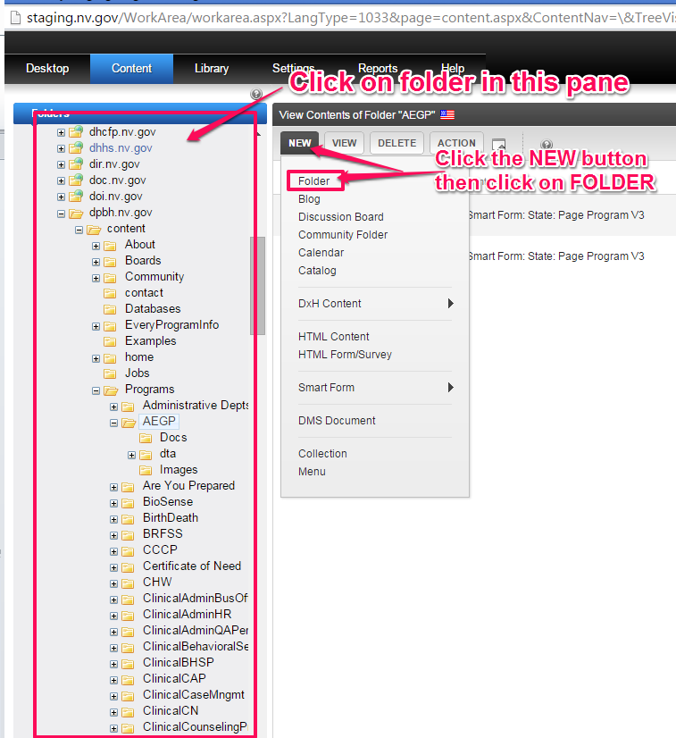
Next, enter the folder name and click the ADD FOLDER button
