- Ektron Staging area is behind the firewall, intranet site, so you will need a VPN from home to modify
- User Logins to the Ektron system will be their E-mail User ID & Password. If you can’t access Ektron because your account is locked, then you need to unlock your email password. Once you do that, you will have access again to Ektron
Logging in and Navigating to your Website Folders
- Each user will only have access in the work area to their program(s) folder ONLY. They will be able to see the rest of the folders, but will not be able to access or change information.
- Users will NOT be able to delete FOLDERS within their program
- All Ektron “How to” documentation is located http://it.nv.gov/web
- Common Templates available:
  - Page Program V3 - (most of the pages will be built using this template
  - Meetings & Agendas
  - Page-FAQs for FAQs
  - Staff List
  - Glossary (acronyms)
- Special templates (mostly for homepage)
  - Carousel
  - Initative Box
  - Slides
  - Links
  - Press Releases
  - You Tube
- We are NOT putting much emphasis on photos, YouTube, Social Media, Widgets at this time as we are trying to get this site into production asap.
- “How to” Training
  - How to review the sitemap w/program coordinator & ensure ALL information that will be common is going to be separate & reside within the common folders
  - How to modify the common pages within the right side folders
    - How to add, change, copy, delete content
    - How to work with the 3 functions of LINK MANAGER
      - External link
      - Link to desktop or shared drive to retrieve pdf, form, photo, etc.
      - Link to page already built within their program
  - Meetings & Agendas
  - Page-FAQs
  - Metadata
  - Glossary for acronyms
  - How to restore content from HISTORY
  - How to overwrite & delete documents from the Library
  - Naming convention of files (no spaces, no special characters, use – Not underscore
  - ANY DELETED information can NOT be recovered.

- Program home folder where xxx=program name/acronym
  - Xxx (space) Home is the homepage where xxx=program name/acronym
  - RC-xxx is the right side of the homepage where common information is listed
NOTE: difference between Regulatory & Programs is Regulatory has Regulatory Partners

- The following folders have been created within the dta folder
xxx folder where xxx is the name of each resource (i.e., Staff; Locations; complaints)
    - Landing page for that resource will be within that folder so all the user needs to do is add/change the information
  - Common folders (this information will be pulled by other main/general pages within the site) – will be listed on right side of your program page – if they do not apply to your program, we can remove them -
NOTE: There needs to only be 1 page within the following folders… if you have multiple grants or meetings or listservs, then you need to build a landing page for each
    - Contact Us
      - Address
      - Staff
      - Locations
      - Listserv
    - General Information
      - Acronyms
      - Boards/Commissions
      - FAQs
      - Policies
      - Statutes
    - Regulatory Partners
      - Partners
    - Resources
      - Community
      - Complaints
      - Forms
      - Grants
      - Inspection
      - Licensing
      - Media
      - Permits
      - Providers
      - Recalls
      - Training & Education

NOTE: we are doing this so we can use the List Summary option on the main Community, Providers, Resources tabs to pull information from every program/regulatory.
IF someone ADDS a new resource on their page, It will NOT appear on any other main resource, community or provider pages unless they let the person responsible for the overall DPBH website know so they can ADD it. Adding it just to a program will ONLY show it on that program.

Keep track of what Resources the program has. If the program does NOT have any of a particular resource, i.e., Licensing, then remove the link on the right side template & make sure this document is updated – Ericka will be the owner (SHEET will be updated when all programs have been identified) 2/3/15
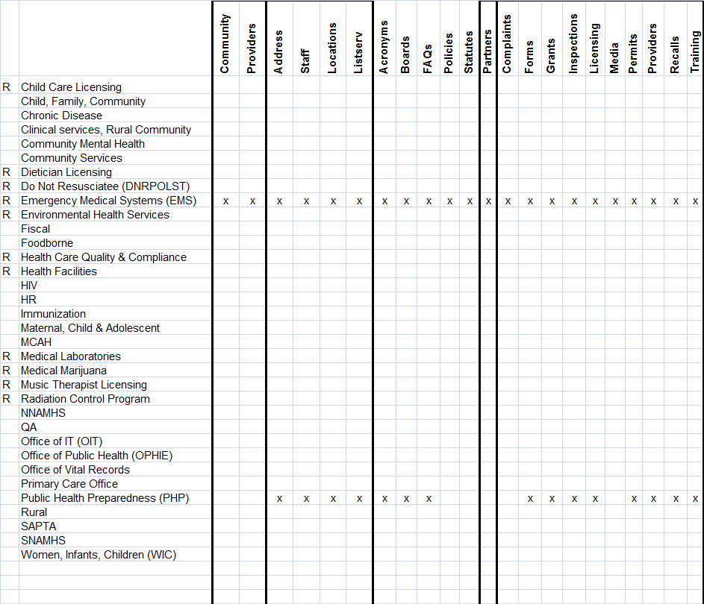

All of the information will be taken from each program & will populate the following resources on the RESOURCE tab:
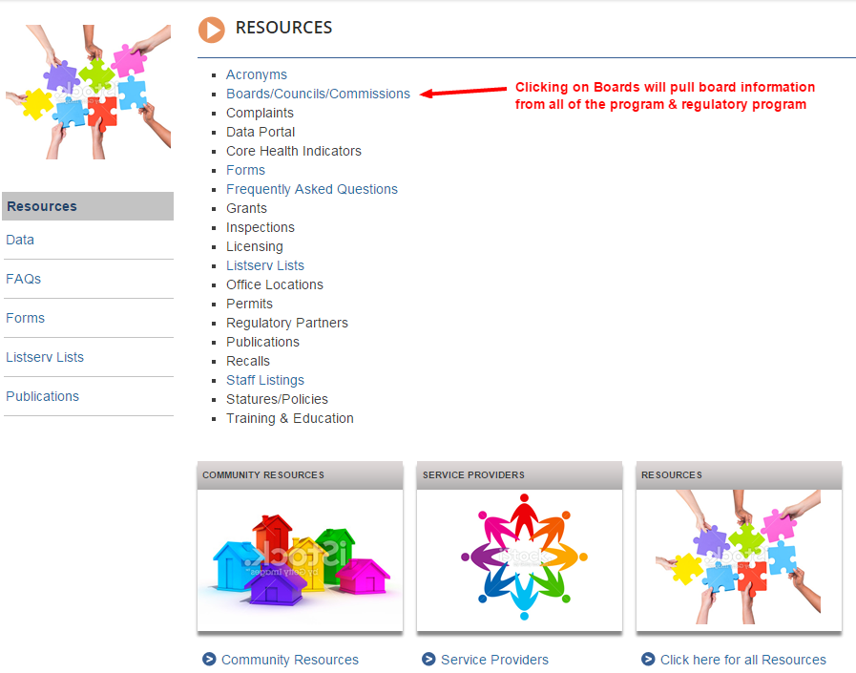When a user clicks on the Boards/Councils/Commissions link on the Resource page, it will populate this page from all of the programs within this site. This information will only live in one place, the board’s folder within that program
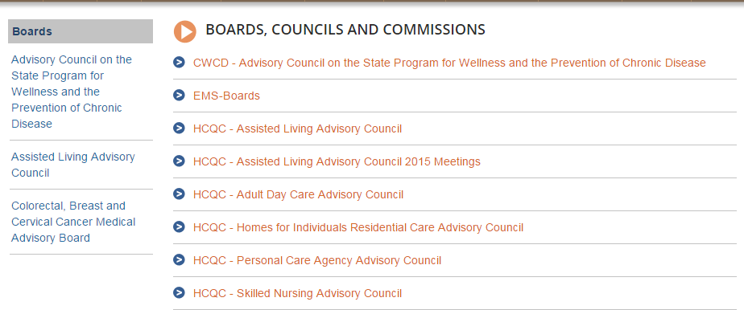
DPBH Workarea Special Organization and Asset upload
Folder Structure:
- Main Folder = XXX - This folder contains the main pages within your section.
  - dta = This folder contains subfolders with right content pages
***ONE PAGE PER FOLDER***
  - docs = for organization of documents
  - images = folder for images to live
  - board = It is suggested that a board folder be created to organize your board/commission/AC information such as meeting and workshop materials - year to year, members page, bylaws.
  - XXX folder = Identifying folders as needed for your group - examples:
forms, training, policies etc. if you feel "docs" is not enough.
Document/image upload how to:
- Navigate to the folder where the web page is that you want to add a link to a new document or image.
- Open the page and select Edit as you have been trained.
- Proceed as you have been trained using the "link manager" to navigate out to your PC to find the document (asset) that you wish to bring in to your site.
- Once the link manager "Add Library" window is open in the right window, you will navigate in the left window to the "docs" (or previously created) folder that your library item will be uploaded to. PAY CLOSE ATTENTION NOT TO UPLOAD TO THE "dta" FOLDER. IT NEEDS TO BE UPLOADED TO THE SPECIFIED FOLDER FOR THE ASSETS.
- You will see that the link manager treats the link the same just the location of the actual document (asset) in the library will be as you have instructed.

When building/displaying Program or Regulatory Program
  - Right hand s/b built 1st as that is information that will be “REUSABLE”
  - Body of the program
    - Basic page – can be anything Except things that are common or reusable somewhere else other than the main body of this program
    - Can add links from the right side to appear on the main body of the program
(examples)
      - Folder=Community (community links)
      - Folder=Provider (provider Links)
      - Folder=Forms (maybe right)
      - Folder=Complaints
      - Folder=Permits
      - Folder=Licensing
    - The links on the right will use a metadata feature & will be appended to main/body of the page
What is Metadata – How do I append the information – click for detailed information
Metadata Example
