Folder Structure:

* Main Folder = XXX - This folder contains the main pages within your section.
  + dta = This folder contains subfolders with right content pages   
    ***ONE PAGE PER FOLDER***
  + docs = for organization of documents
  + images = folder for images to live
  + board = It is suggested that a board folder be created to organize your board/commission/AC information such as meeting and workshop materials - year to year, members page, bylaws.
  + XXX folder = Identifying folders as needed for your group - examples:

forms, training, policies etc. if you feel "docs" is not enough.

**Document/image Upload Procedure Option 1**:

1. Navigate to the folder where the web page is that you want to add a link to a new document or image.
2. Open the page and select Edit as you have been trained.
3. Proceed as you have been trained using the "link manager" to navigate out to your PC to find the document (asset) that you wish to bring in to your site.
4. Once the link manager "Add Library" window is open in the right window, you will navigate in the left window to the "docs" (or previously created) folder that your library item will be uploaded to. **PAY CLOSE ATTENTION NOT TO UPLOAD TO THE "dta" FOLDER. IT NEEDS TO BE UPLOADED TO THE SPECIFIED FOLDER FOR THE ASSETS**.
5. You will see that the link manager treats the link the same just the location of the actual document (asset) in the library will be as you have instructed.

**Document/image Upload Procedure Option 2**:

***Summary: Uploading documents to the system is a 3 step process:   
(1) Rename the documents, (2) upload documents, and (3) link documents***

1. Rename all files to be uploaded so there are ***no spaces or special charters other than a dash (-) or an underscore (_) in the file name***. Spaces in file names can cause future broken links.
2. Use the following Document Upload procedure to upload each document to the "docs" (or previously created) folder in the workarea.
   1. Log in to Ektron and open the workarea, click the Library tab at the top the window

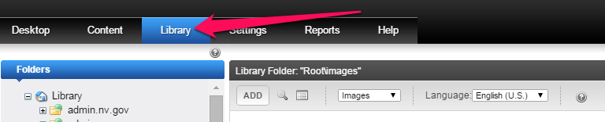

* 1. In the Workarea, in the left pane navigate to the ‘Docs’ folder (images upload to the images folder instead) for the appropriate program and then in the left pane use the drop-down to change images to files.

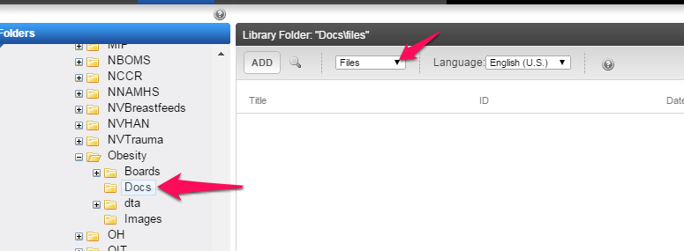

* 1. Click the Add Button

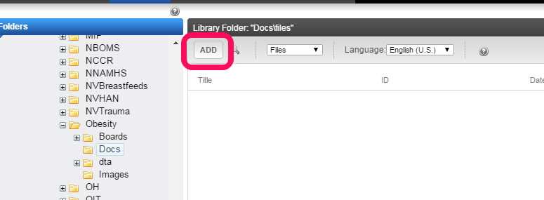

* 1. Enter the document title in the Title field, then click the “Choose File” by navigating through the link manager as you have been trained.

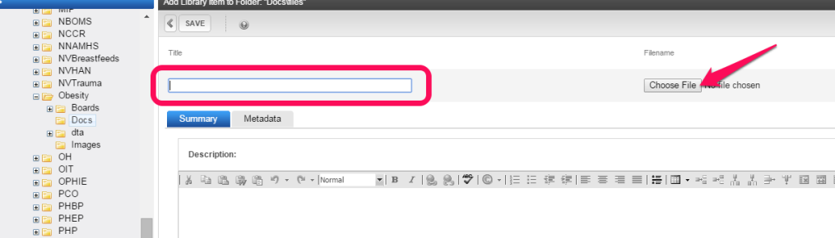

* 1. Click the save button

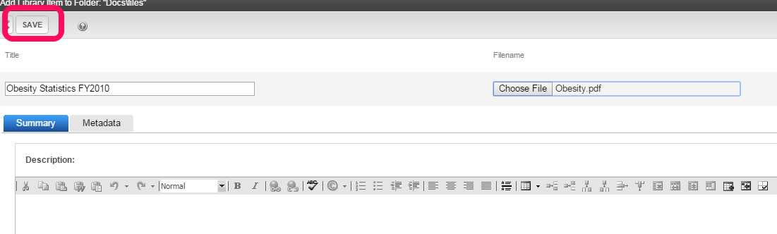

* 1. Repeat these steps for each document you want to upload.

1. Add the link to the content area
   1. In the Workarea, click the CONTENT tab

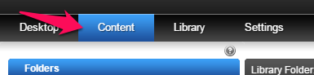

* 1. Navigate to the folder where the content block that you want to add a link to a new document or image. In this example we are adding a report to the Publications section of the program so we open the dta folder and click on the Publications folder.

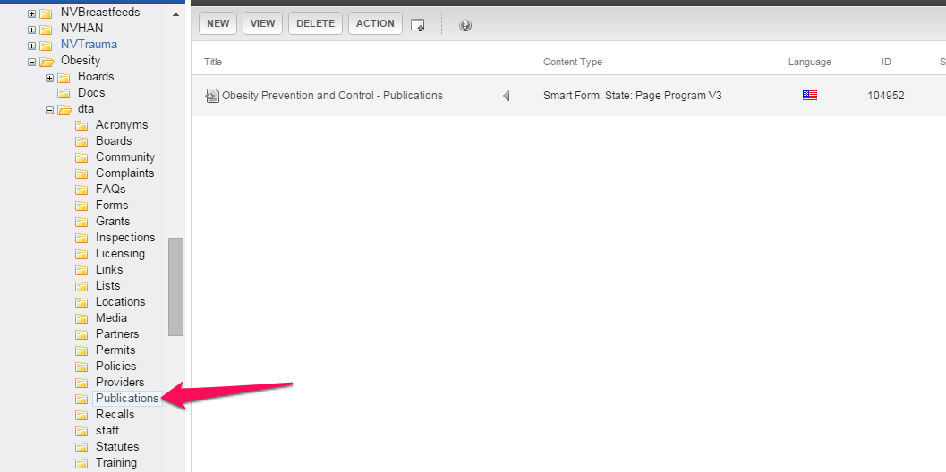

* 1. Open the page and select Edit as you have been trained and use the "link manager" to navigate to the Docs folder and choose the document (asset) that you wish to upload.
     1. Enter the title and then click on the URL button

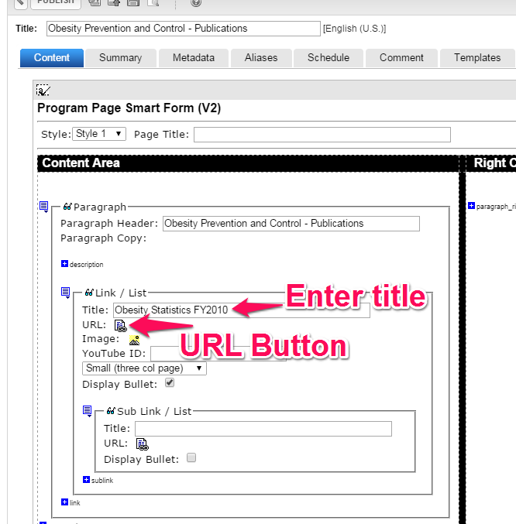

* + 1. In the Link Manager, enter the title in the Tooltip field and then click the URL button

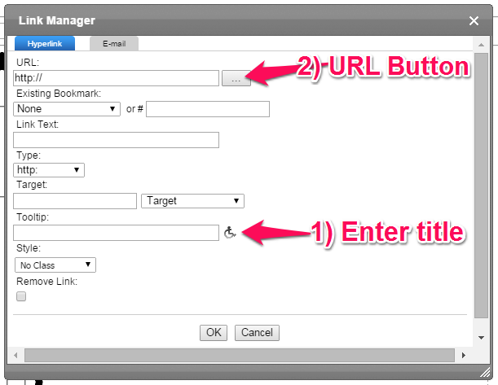

* + 1. In the left pane navigate to the appropriate program folder and click the ‘docs’ folder

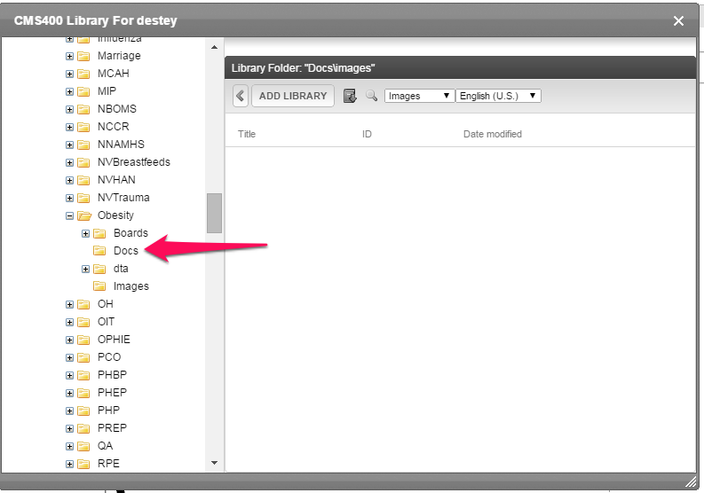

* + 1. In the right pane click the drop-down button and change “images” to “files” and scroll as necessary to locate the specific document you want to create a link to.

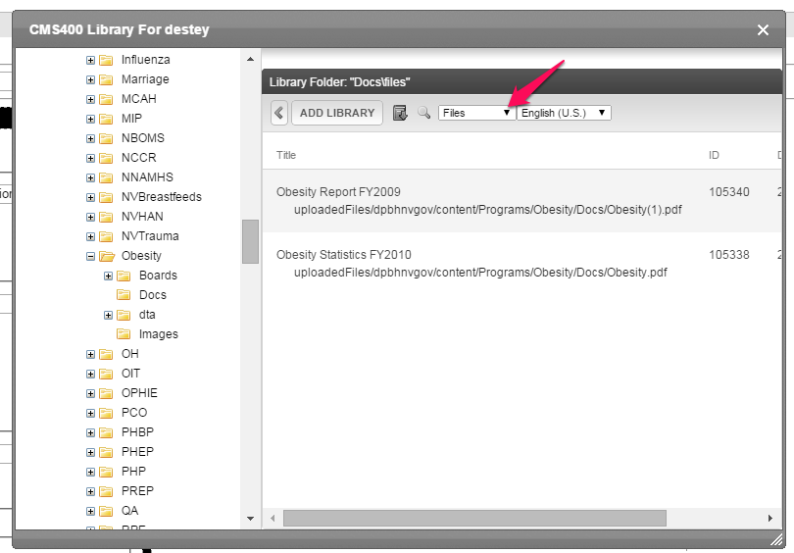

* + 1. Double-click the name of the document you want to create the link to

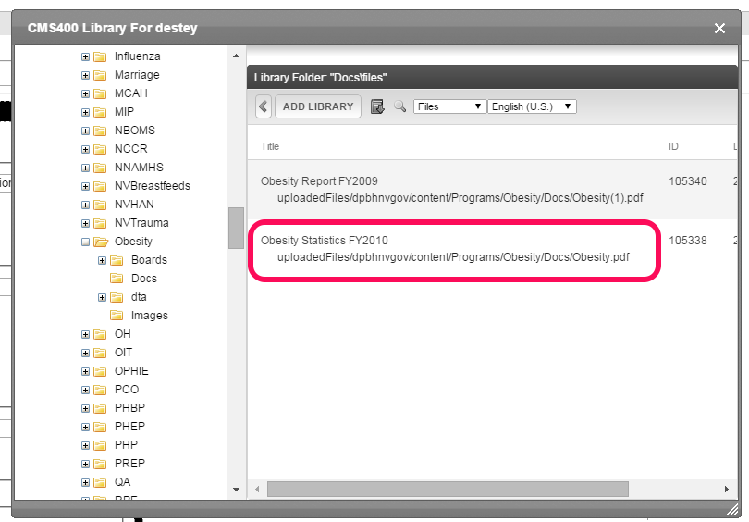

* + 1. When the Link Manager dialog box appears, click the OK button.

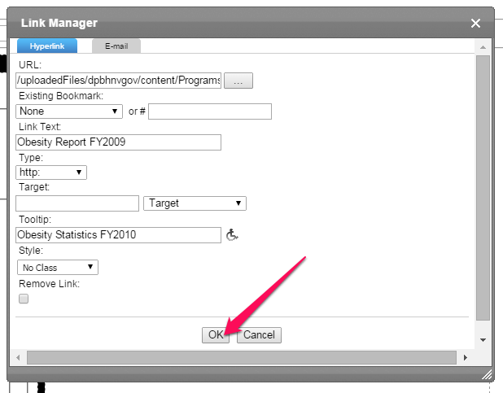

* + 1. Repeat these steps for each document you want to add to a particular content block.