- Locate the analytics for review.
- Determine the top ten pages users visit
- Choose the Homepage Quick links from those top ten pages that users visit the most.
- In the Ektron Workarea navigate to the home > features folder click on the content block entitled “HPLinks”
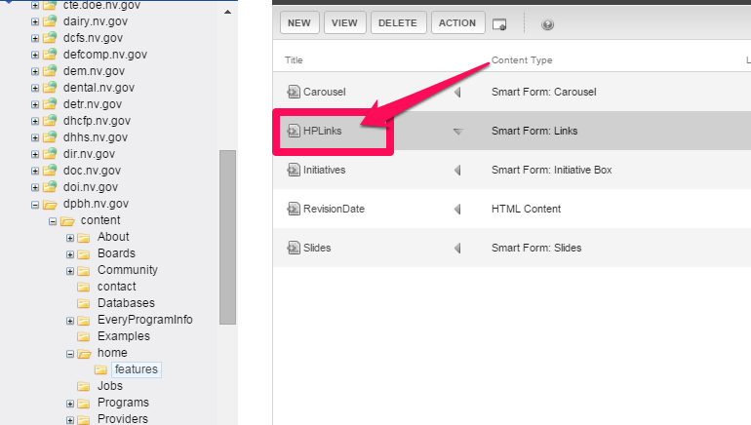
- Click the EDIT button
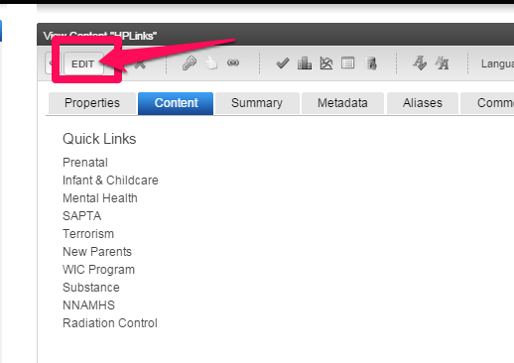
NOTE: you may need to remove a link in order to add a new one otherwise too many items in this section will push down the content and carousel on the homepage leaving prime website real estate space empty and creates a poor webpage format.
- To add a new link click the call out button above or below where you want to insert the new link and choose the appropriate selection (Insert Above or Insert Below).
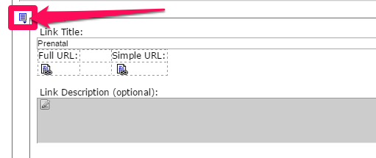
- To delete a link, click the call out containing the link to be deleted and choose REMOVE from the drop-down menu.

