Note: All slide images should be 600 x 300 pixles. All carousel images should be 180 x 180 pixels.
- In the Ektron workarea navigate to the home > features folder
- Carousel - Add a photo from the carousel
  - Click on the content block entitled “Carousel” and click the EDIT button.
  - To add an image to the carousel, click on the CALL OUT button in a section above or below where you want to add another and then select INSERT ABOVE or INSERT BELOW
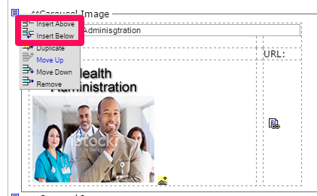
  - Enter a title for the carousel image
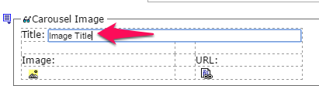
  - Click the yellow Image Icon button
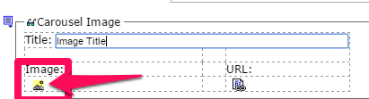
  - In the CMS400 Library dialog box click the ADD LIBRARY button
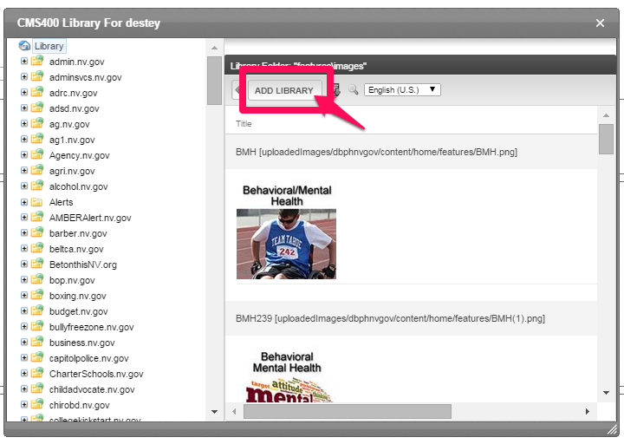
  - Enter the image title in the Title field
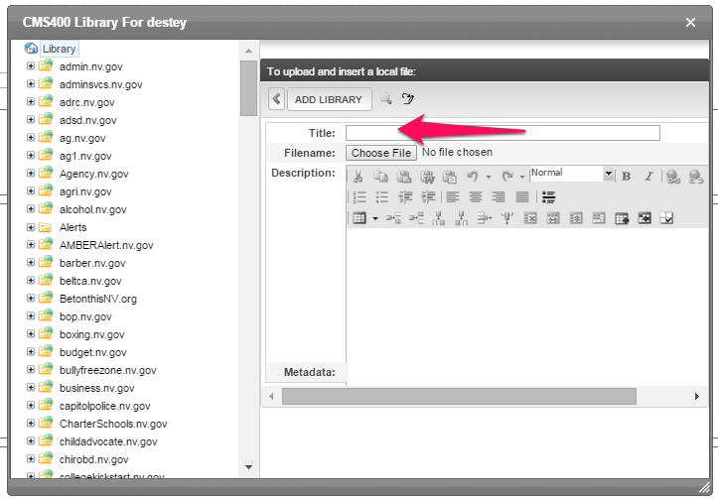
  - Click the Choose File button.
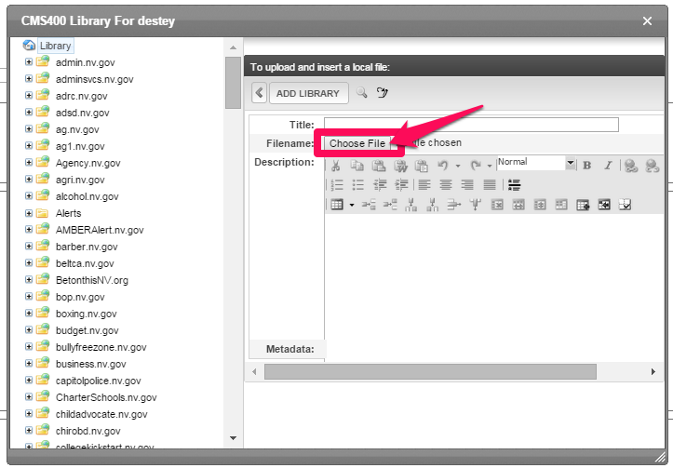
  - Next, navigate to the image you want to upload and select the image and click OK.
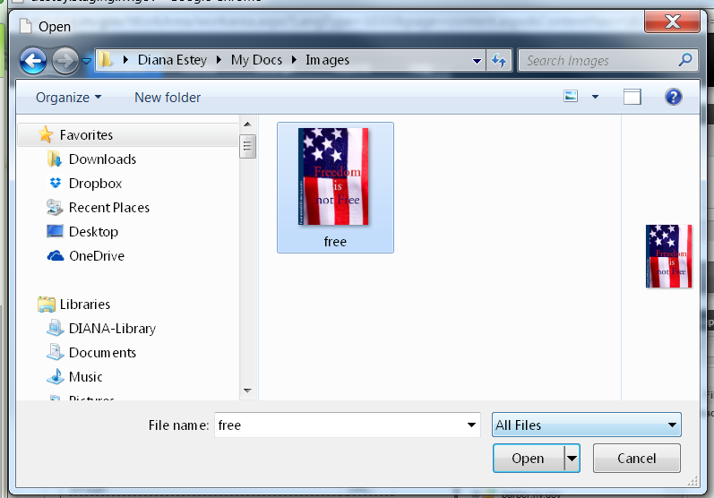
  - The file name will populate the area next to the Choose File button. Click the ADD LIBRARY button and the image has been added to the carousel.
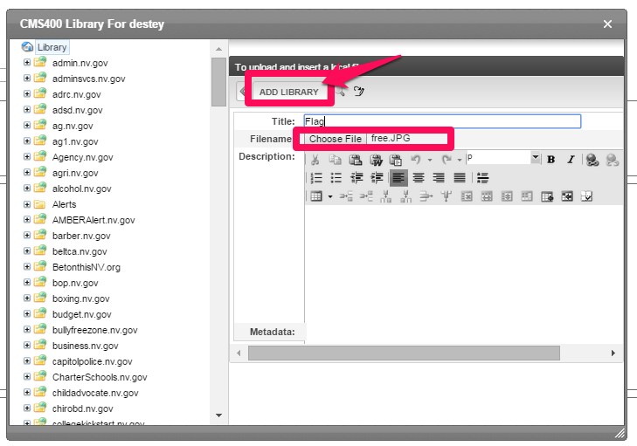
  - Click the PUBLISH button
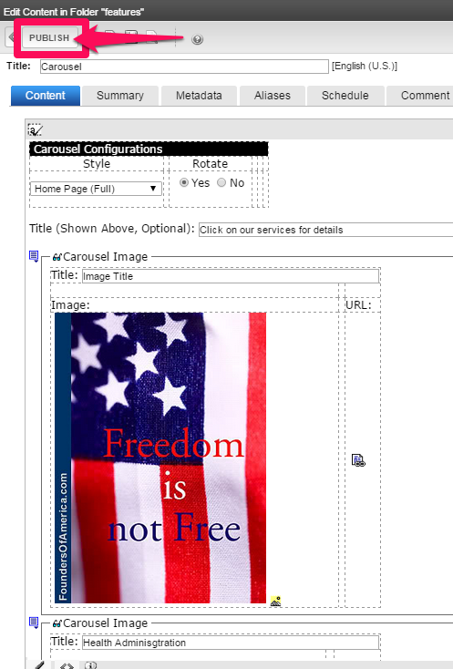
- Carousel - Delete a photo from the carousel
  - To delete an image to the carousel, click on the CALL OUT button in the section that contains the image to be deleted.
  - Select REMOVE from the drop-down menu.
