- Make sure that ALL programs/regulatory homepages are formatted the same, wherever possible
- Identify ALL common areas across all programs & regulatory programs:
  - That information will appear on the homepage of every program (right side) i.e., main categories: Contact, General Information, Resources
  - That information will also appear on other program pages that will be created. Those pages will link back to all of the programs & regulatory program’s information resides in that program’s area.
    - Examples: Contacts (will list all staff listings from programs); Acronyms, FAQs, ForMS, Listservs
      - Example: Contact - http://dpbh.staging.nv.gov/contact/Contact/
      - Example: Listservs - http://dpbh.staging.nv.gov/Resources/Listservs/
- Make sure that ALL information for a specific program resides in that program’s work area so it can be maintained by that program section Administrator(s)
- If it is information/data that will be accessed by other areas, build that content separately from the main program page (2)
  - This will ensure that there will only be ONE copy/version of this data
  - Other areas will be able to link to that program’s content from other pages within the site
  - Example: has Community Resources listed on their home page, but the Community Tab also displays the same information
    - PHP homepage - http://dpbh.staging.nv.gov/Programs/PHP/PHP-Home/ (p11)
    - Community homepage - http://dpbh.staging.nv.gov/Community/Resources/ (p12)
- Ektron only links to existing applications, the applications does not live in Ektron. If an application exists in the current Health website, it must be moved & maintained at a different location
  - Example: WIC has an online database in an outside vendor website they maintain
- Interactive forms are available within Ektron.
  - Example: Ektron On-line form (sends replies to a specific email, then deletes information)
  - Example: Google On-line form (send it to GOOGLE drives, which allows the review & manipulating of the results) (download to Excel, do queries, etc.)
- When new website goes live, the old Health & Behavior Health websites, including applications, will not be available to the public. Their URLs will be redirected to the new URL, http://dpbh.nv.gov. That means if you have anything you need to save from the old website, you need to save it before the new site goes live.
- If you want a backup/copy of the entire existing Health and/or Behavioral websites, you need to put a helpdesk ticket in to EITS helpdesk to ensure the site will be backed up & the backup tape will be held indefinitely as tape backups are recycled.
Nevada Division of Public and Behavioral Health (DPBH)
Every website that is built in the State’s Content Management System (CMS) is built from a user provided sitemap(s). The Web Group will then build a multi-site for this new site in Staging (test environment behind the state’s firewall; setup the defaults for the site; and then frame the site within the Ektron Staging Work area.
All of the main menu topics, i.e., Home, About, etc. will become FOLDER names, and all of the subsequent content will be built within that folder. That way the user can find the content they need to modify.
All main topics (menu), i.e., Home, About Us, etc. will also have a “Landing Page”, so when a user clicks on that main menu topic, it will display the page with explanation & all of the content & its information & links.
All main topics (menu) will appear on EVERY page within the Website.
NOTE: this sitemap is a ‘high level’ sitemap and does NOT have links back to the old site for each page, but normally it would.
- Home – http://dpbh.staging.nv.gov (Links to external websites)

  - Department of Health & Human Services
  - State of Nevada
  - Governor Sandoval
  - Program Resources
- About - http://dpbh.staging.nv.gov/About/About_Us/

  - Our Organization
    - Program Guide
    - Organizational Charts
    - Chief Medical Officer/Administrator
    - Medical Epidemiologist
    - Grants and Funding
- Programs (ALL PROGRAM INFORMATION WILL LIVE HERE)
  - Health Administration
    - Fiscal Services
    - Human Resources
    - Quality Improvement and Performance Management
    - Office of Information and Technology (OIT)
  - Behavioral/Mental Health
    - Clinical Services, Northern Nevada Adult Mental Health Services (NNAMHS)
    - Clinical Services, Southern Nevada Adult Mental Health Services (SNAMHS)
    - Rural Community Health Services (Children, Adolescent and Adult Services)
    - Community Mental Health Administrative Services
    - Substance Abuse Prevention and Treatment (SAPTA)
  - Children and Family
    - Bureau of Child, Family, and Community Wellness
    - Maternal, Child, and Adolescent Health
    - Women, Infants, and Children (WIC)
  - Disease and Illness
    - HIV/AIDS Prevention and Ryan White Part B
    - Office of Public health Informatics and Epidemiology (OPHIE)
    - Nevada Foodborne Illness Defense and Surveillance Workgroup

  - Health and Wellness
    - Chronic Disease Prevention and health Promotion
    - Clinical Services, Rural Community Health Services
    - Community Services
    - Immunization Program
  - Offices of Vital Records, Primary Care, and Preparedness
    - Public Health Preparedness
    - Office of Vital Records
    - Primary Care Office

- Community (This page is just LINKS back to content living under Programs/Regulatory)
  - Community Resource links from programs & regulatory programs
- Providers (This page is just LINKS back to content living under Programs/Regulatory)
  - Provider Resource links from programs & regulatory programs
- Boards, Councils & Commissions
  - List of boards from all program & regulatory programs
- Regulatory (ALL REGULATORY PROGRAM INFORMATION WILL LIVE HERE )
  - Regulatory Programs
    - Environmental Health
    - Emergency Medical Systems (EMS)
    - Health Care Quality and Compliance (HCQC)
    - Medical Marijuana
    - Radiation Control Program
  - Regulatory Partners
    - Partners
  - Regulatory Information
    - File a Complaint
    - Inspections
    - Licensing
    - Permits
- Resources
  - Data
    - Portal
    - Core Health Indicators
  - Forms
    - Forms (list of all forms from all of the programs & regulatory programs)
  - Frequently Asked Questions
    - FAQs (list of all FAQs from all of the programs & regulatory programs)
  - Listserv
    - Lists (list of all Listserv from all of the programs & regulatory programs)
  - Publications
    - 2015
    - Prior Years
- Contact
  - Main Office Locations?
  - Staff Listings (list of all Staff listings from all of the programs & regulatory programs)
- Sitemaps (temporary) will be removed once all of the sitemaps have been received

DPBH HOMEPAGE – http://dpbh.staging.nv.gov
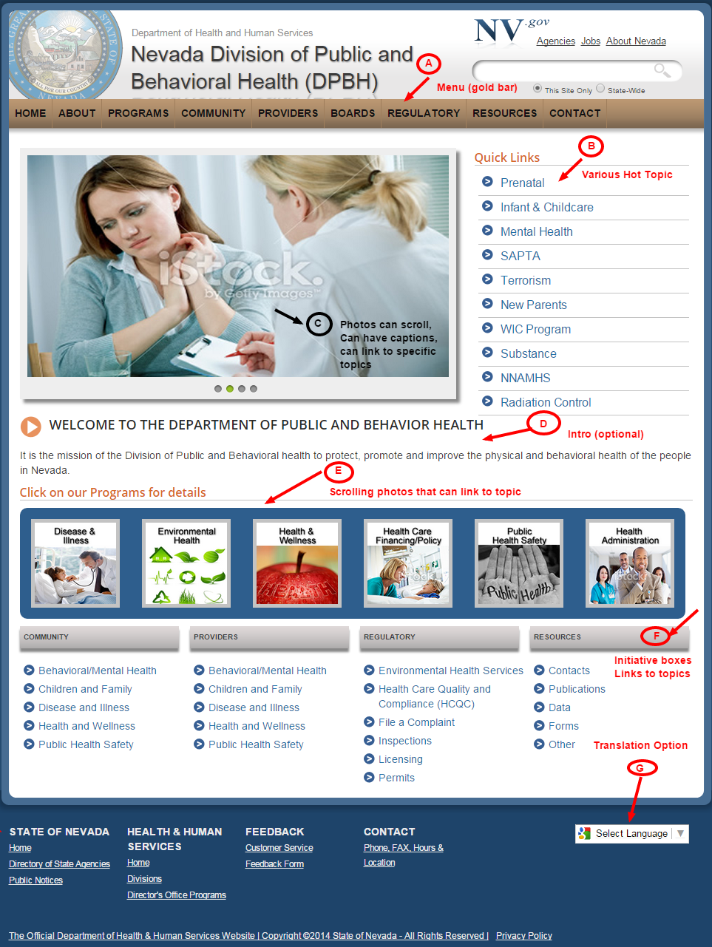
DPBH Homepage - http://dpbh.staging.nv.gov/
A – Web Site Main Menu – Web Site Navigation – Stays with everry page of the website
Home|About|Programs|Community|Providers|Boards|Regulatory|Resources|Contact
If you click a Menu item, i.e., Programs -> it will link to a “Landing Page” with all of the related information
Any information that appears when you hover over a menu Item, i.e., Programs, will appear on the Landing Page
i.e., Programs will have Links to Health Administration; Behavioral/Mental Health, Children & Family, etc.
B – Quick Links – Popular links used often – Ektron can provide users GOOGLE Analytics so users can review reports and help determine what your customers are looking for – those are what should be listed here!
- Prenatal
- Infant & Children
- Mental health
- SAPTA
- Terrorism
- New Parents
- WIC Program
- Substance
- NNAMHS
- Radiation Control
C – Scrolling photos – Rotating photos w/caption & links – can be updated by DHHS staff
Optional – Select by User
D – Welcome Message – Area where you can add a message, mission, etc.
E – Click on our Programs for details (carousel of main categories)
- Health Administration
- Behavioral/Mental health
- Children and Family
- Disease and Illness
- Health and Wellness
- Office of Vital Records, Primary Care, and Preparedness
- Regulatory Programs
NOTE: this carousel will appear on the PROGRAMS & REGULATORY landing pages only
F– Initiatives – Quick links by topic – these links are also in the main menu (top gold)
- Community
- Providers
- Regulatory
- Resources

Footer – “sitemap” or branding of the site across Departments – stays with every page of the website

G– Google Language Selector /Social Media Links – Allows all text within the site to be converted to a list of Languages available
- Pros and cons of Google Translate: http://www.redlinels.com/2012/05/16/pros-and-cons-of-google-translate/
- Social media links
  - Dept. of Agriculture - http://agri.nv.gov/

Small Footer – stays with every page of the website
- Copyright information
- Can contain links to ‘intranet’, etc.

DPBH Program Homepage – Example “Environmental Health” - It is created in the State’s CMS by Web staff based on the user’s Sitemap.
Main Area
Free form area when button, text, YouTube, etc. information can be entered. When subsequent pages are built, you would come back to this main page & link it here
Right Side
*A-Contact information – should add an address, staff locations, office locations
*B-General information – Statutes, Acronyms, FAQs, Meetings, News
C-YouTube examples – can add a YouTube link here (user controlled)
D-Resources – Links, photos, YouTube, whatever is considered a resource for your area
E-Widgets – Go to a specific website & get the IFRAME for the widget to appear
F-Three boxes – (Optional – can add boxes & links)
G-Add a carousel (Optional)
Left Side
Automatically created by system/Templates (will have the same links as the HOVER when you hover over the Menu (gold bar).
H-Photo of Program (same as Carousel photo – optional)
I – Secondary Menu = drop down categories on that Menu Option (Regulatory)

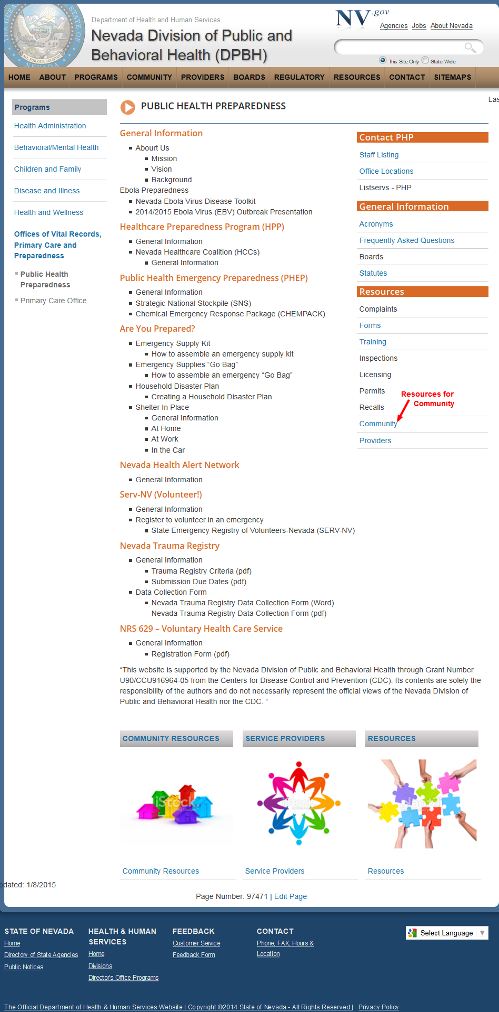
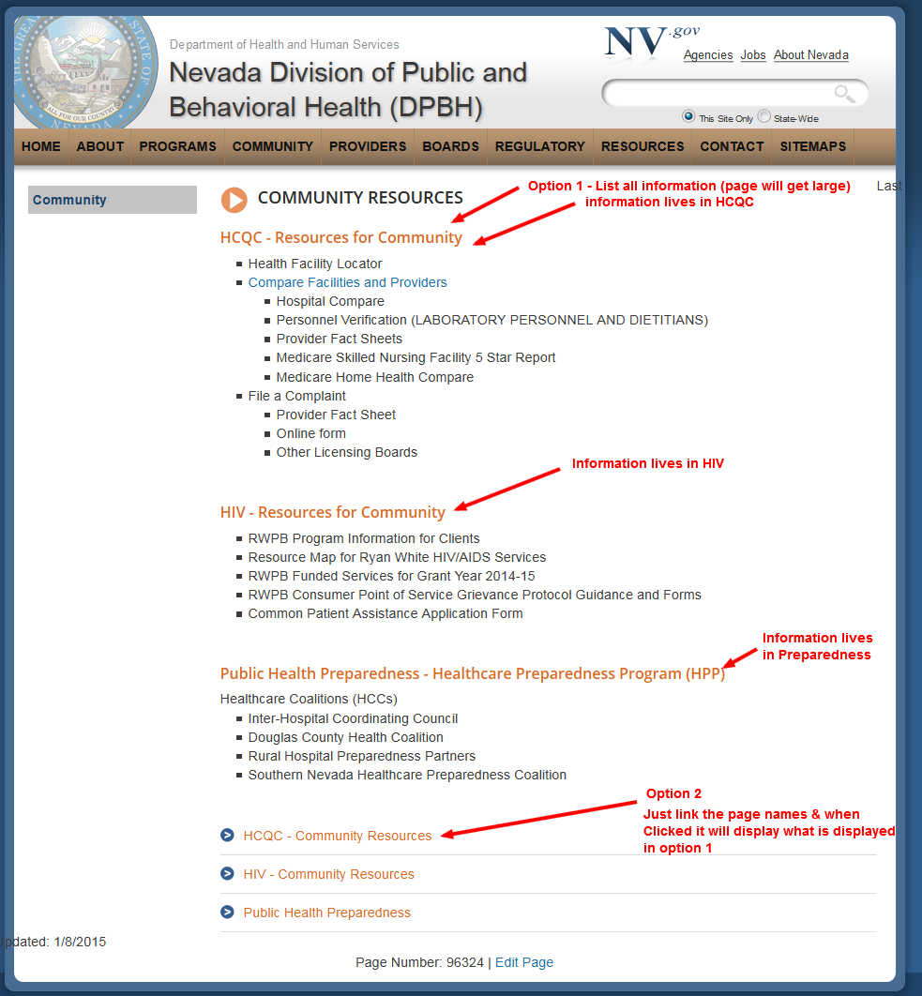
Tools available to Users
- Multiple Environments
  - Staging Environment - http://staging.nv.gov
    - behind the firewall – need Silver net access or VPN from remote location
    - Where all updates to Ektron are done by EVERYONE
    - Allows user to update & review modifications BEFORE they go into production
  - Production Environment
    - Live – internet
  - Move content from Staging to Production
    - By a SYNC process which takes the published content from Staging to Production automatically based on schedule posted on http://staging.nv.gov/
    - Lists ALL Sync time (M-S) This sync times might change depending on requests from Users

- Ektron Templates that are available to our users
  - http://agency.nv.gov/Pages/Pages_-_Smart_Forms/
- Want to see what other Ektron State users are doing? This is a great option as it will give you ideas of how others are handling things that might work for you too!
  - http://staging.nv.gov/tools/sites.aspx
    - If it is ONLY listed under Staging, then the site is NOT live yet
    - Can click on any of the sites to review
- Practice Website – This site as developed for users to use during training sessions, or on your own if you wish to play & test Ektron’s functionality
  - http://it.nv.gov/web/, then go to Ektron Practice Website
  - Click on Ektron training – How the Web Group Does IT for detailed documentation
- Ektron templates are using “Metadata”
  - How Metadata works in Ektron to bring in content from other pages - http://it.nv.gov/uploadedFiles/IT.nv.gov/Content/Sections/Application_Development/Web/How%20Metadata%20works.pdf
  - How to documentation on Metadata - http://it.nv.gov/uploadedFiles/ITnvgov/Content/Sections/Application_Development/Web/Procedures/Metadata-PageTitle_Keywords_Description.pdf

- Ektron templates/smart forms allows our users to add, update & maintain their own website
  - No special tools are needs, only a browser
  - Users just ‘fill in the blanks’ and Ektron will take the data entered & render the page
    - http://it.nv.gov/uploadedFiles/ITnvgov/Content/Sections/Application_Development/Web/Procedures/Quick%20Reference%20for%20Adding%20Content%20to%20your%20Ektron%20website.pdf
Example: How the Smart form works
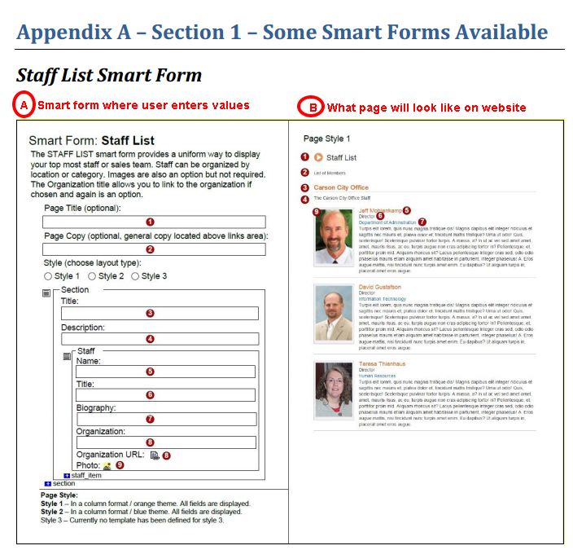
- Ektron User Documents
  - Extensive Ektron on-line User Documentation available – http://it.nv.gov/web/
  - Step-by-step “How to” information that is available on-line, 24x 7
  - Maintained by the Web Group
  - Web Group can also use Join.Me to assist users on-line
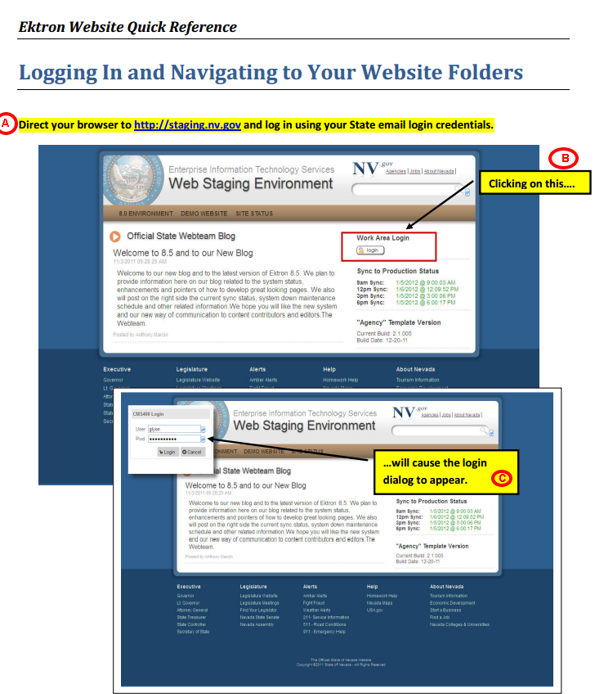
- Forms
  - Ektron has the ability to create Forms/Surveys – Results are Emailed to User
    - Gov:Invite the Governor - http://gov.nv.gov/Contact/Invite/
    - Gov: Request a Proclamation - http://gov.nv.gov/contact/proclamation/
    - AG: Speaker Request Form - http://ag.nv.gov/Speaker_Request/
    - AGRI: http://agri.nv.gov/Plant/PEST/Termite_Pretreatment_Notification/
  - Google Drives has ability to create Forms/Surveys – Results are written to a file on Google Drives. That way the user can retrieve the information; download it; modify it, etd.
(Secure -(https)
    - Survey-IT: http://it.nv.gov/Customer_Service/Google_Survey/
    - Conference Registration-AGRI: http://agri.nv.gov/ILIA/
  - Complaint Form-AGRI: http://agri.nv.gov/Protection/Petroleum_Technology/Petroleum_Complaint_Form/
- Videos
  - Videos can be uploaded to YouTube and included in your website. That way you DO NOT pay for bandwith
- FLICKR – Photos
  - Dept. of Agriculture - https://www.flickr.com/photos/nevdeptofagri/
  - Dept. of Public Safety – http://dps.nv.gov/media/Photo_Galleries/
- Social Media
  - Facebook
    - AGRI: https://www.facebook.com/NevadaDepartmentofAgriculture
    - AG: https://www.facebook.com/NVAttorneyGeneral
  - Twitter
    - DEM: http://dem.nv.gov/
    - AG: http://ag.nv.gov/Home/Features/Social_Media/
    - AGRI: http://agri.nv.gov/Outreach/Outreach_Home/
    - NV.GOV - http://nv.gov/
  - RSS feeds – NOTE: each browser will display these feeds differently
    - Gov: http://gov.nv.gov/News-and-Media/rss/press-releases/

