Overview:

Each program or Regulatory landing page can have an image or logo posted in the left hand corner of the page above the left navigation. There are four parts to creating an image for a landing page:
- Size the image to 180 pixels x 180 pixels
- Upload the image to the Program image folder
- Create an html content block to hold the image
- Add the html content block to the Program Landing Page Metadata in the Left Content area



Step 1 – Size image
- Using a graphics software program size the image so it is 180 pixels by 180 pixels.
  - To do this create a new image that is exactly 180 x 180 pixels
  - Then size the image itself either the top or side measure is 180 pixels
  - Copy the resized image and past it into the new image block created in step A.

Step 2 – Upload the image to the Program ‘IMAGES’ folder
- In the Ektron Workarea, click on the LIBRARY tab
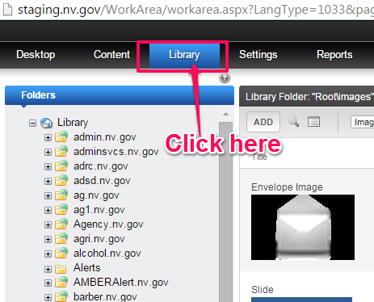
- navigate to the appropriate program or regulatory folder and then click on the ‘IMAGES’ folder
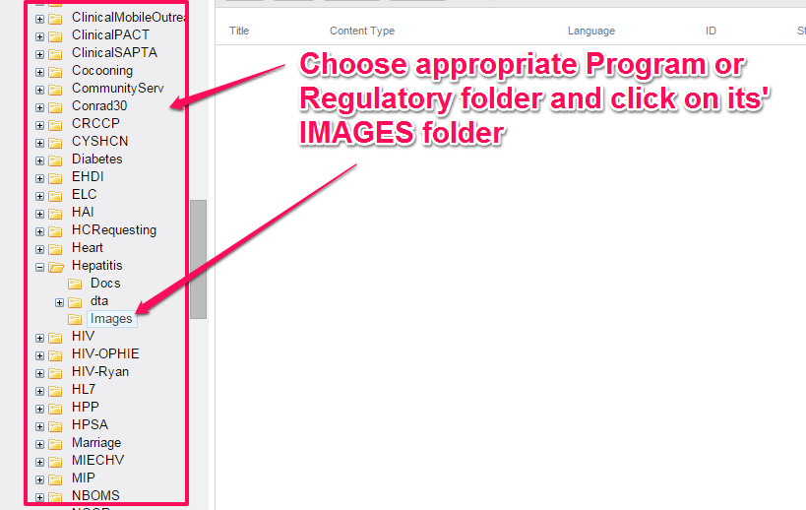
- Click the ADD button
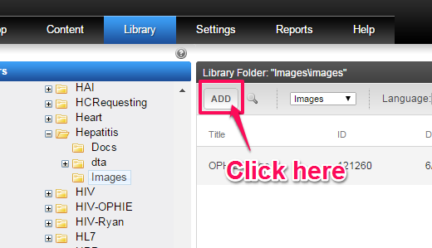
- Enter the Image Title and then click on “CHOOSE FILE” and navigate to locate the file to be uploaded.
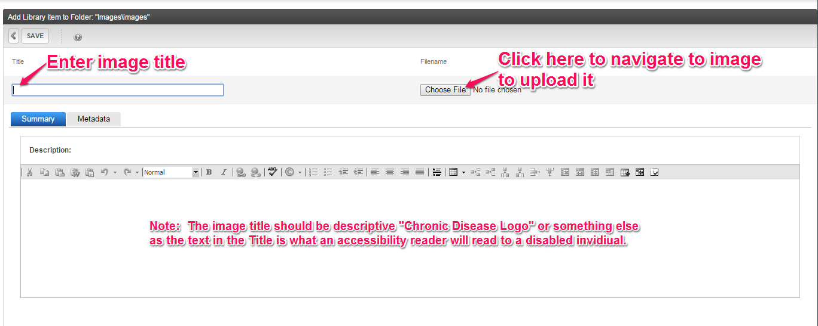
- Once you’ve chosen your document and returned to the window below, click the SAVE button to upload the image to the system.
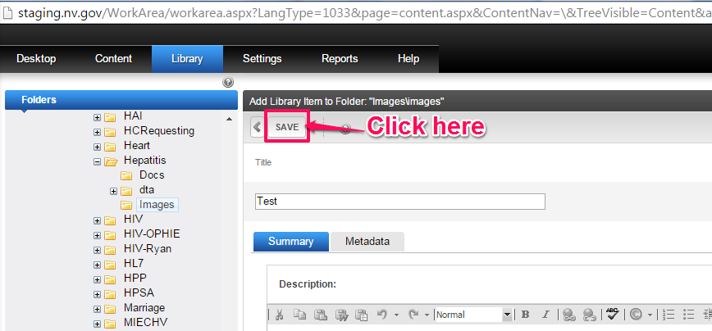
Step 3 – Create the html block to contain the image
- In the Ektron Workarea, click on the CONTENT tab
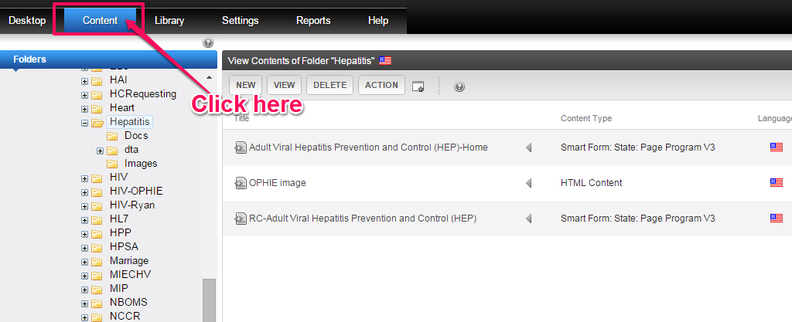
- Then navigate to the program folder you added the image to.
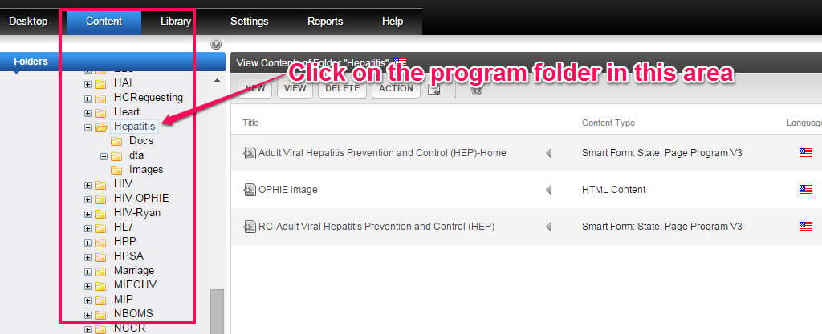
- In the right pane, click on the NEW button and choose HTML Content.
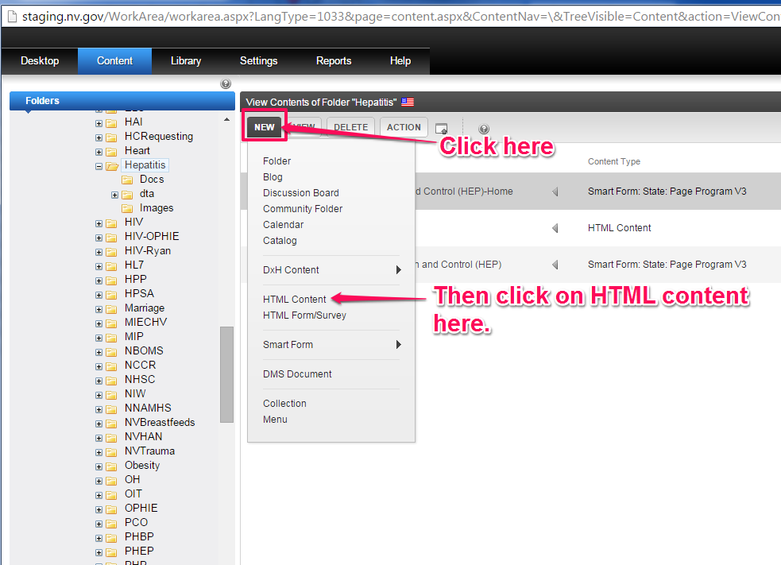
- Enter the content block title. Use something similar to “NVWellness Logo” or another descriptive name that depicts what the image means.
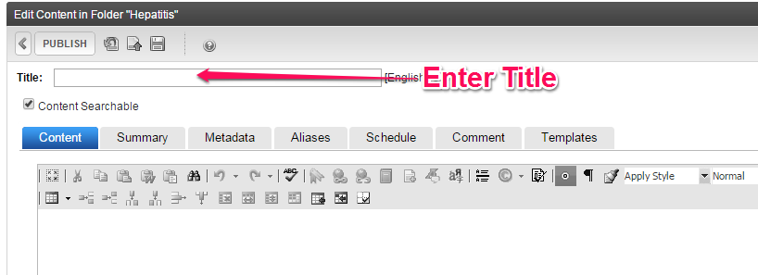
- Next, click in the white space below the icon toolbars.
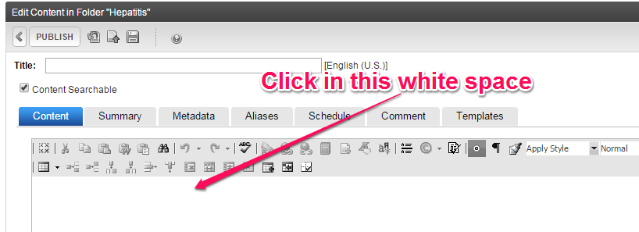
- Click the center icon on the toolbar
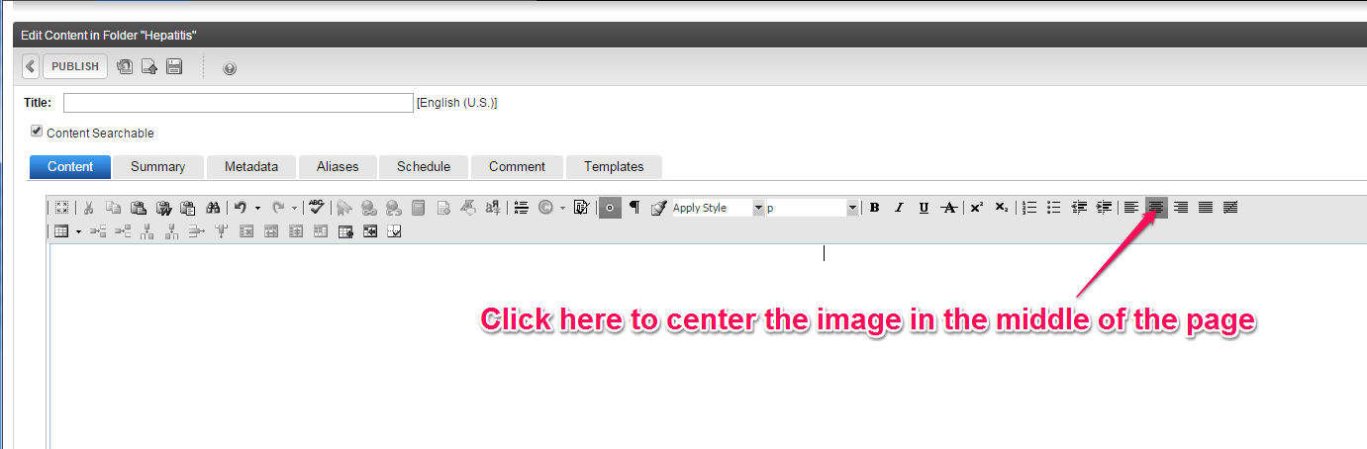
- Then click the Library button.
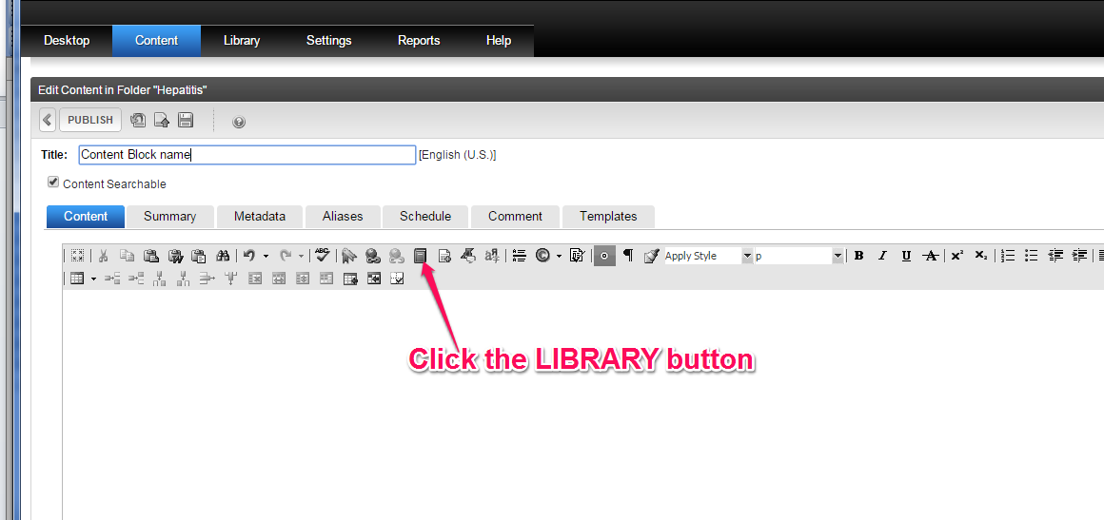
- Navigate to the image folder where you uploaded the image and double-click to select it.
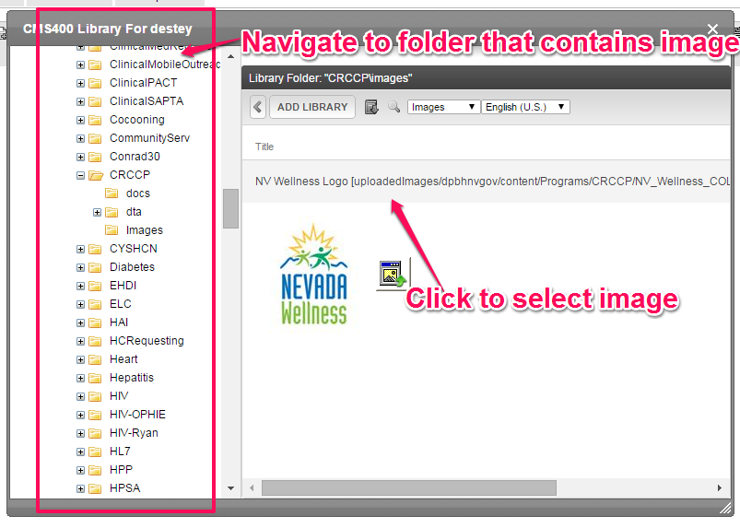
- Click the ADD LIBRARY button
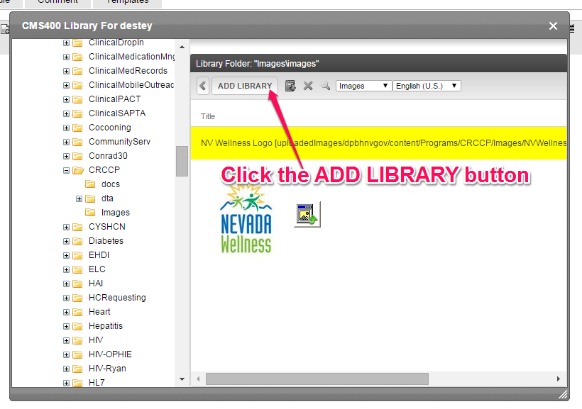
- The image will appear centered in the content block. Click the PUBLISH button.
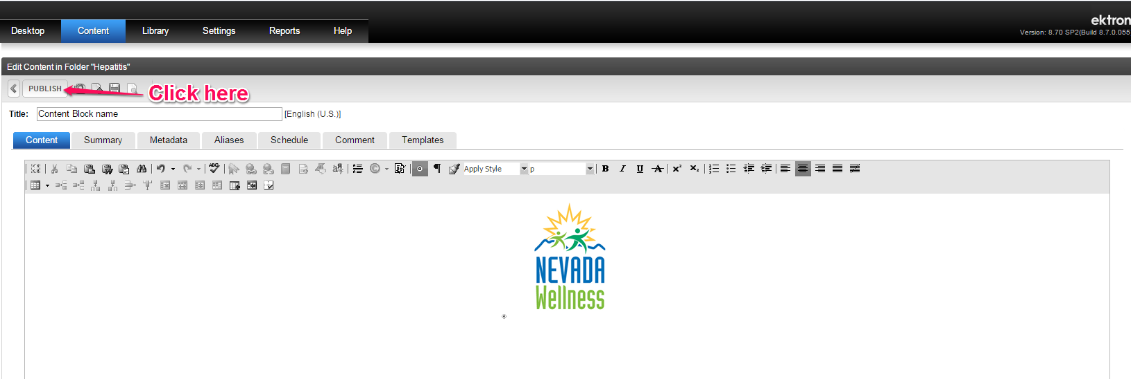
Step 4 – Display the image in the Left Content area of the Landing Page using Metadata
- In Ektron navigate to the folder that contains the landing page you want to add the image to.
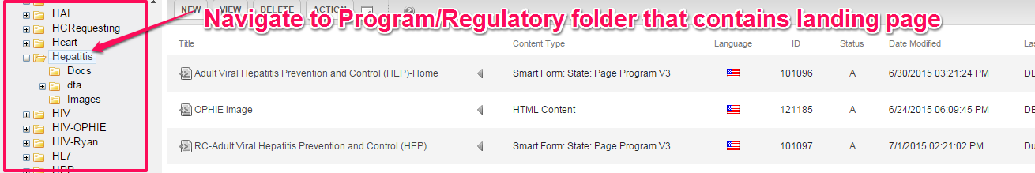
- Click on the name of the Landing Page
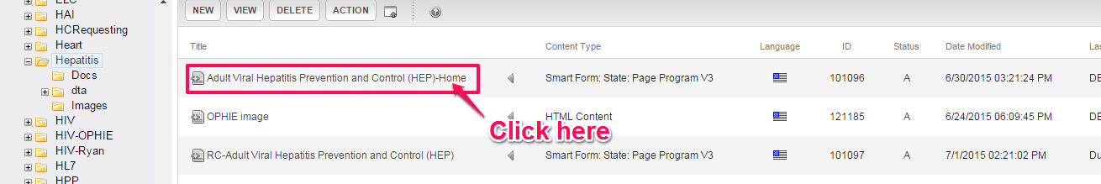
- Then click the EDIT button
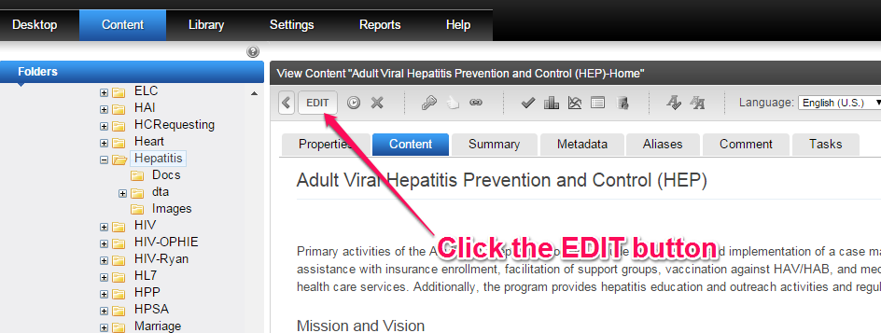
- Click on the Metadata tab
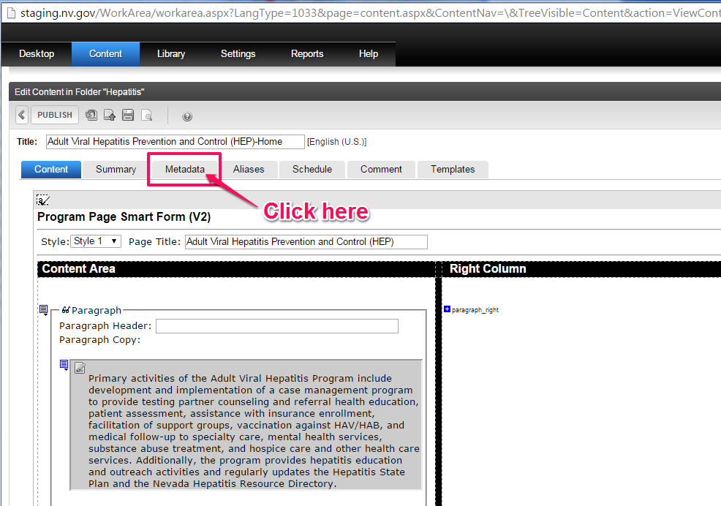
- Scroll down to the Left Content section shown below and click the EDIT button
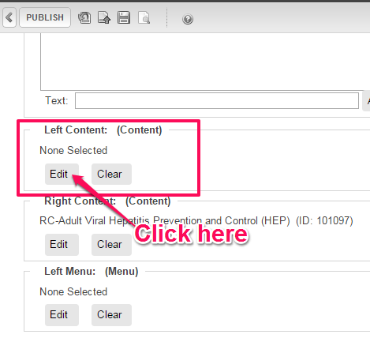
- Click on the image html content block created in step 3. Then click the INSERT button.
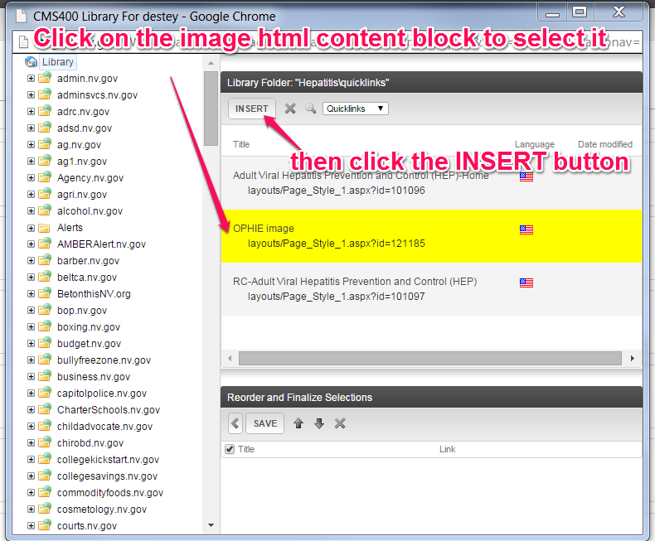
- Once the image populates the Reorder and Finalize Selections pane, click the SAVE button.
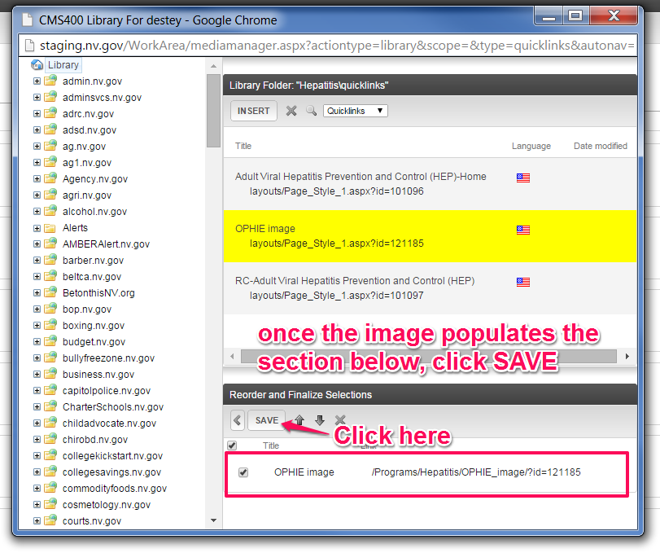
- The image will appear in the Left Content section as shown below. Click the PUBLISH button
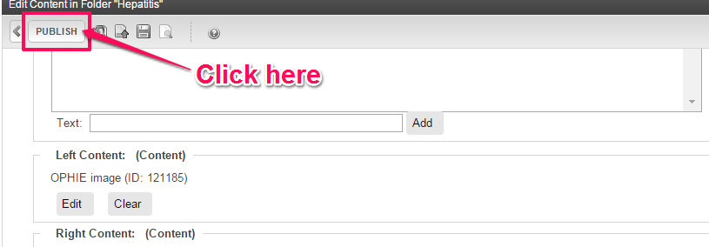

The image should appear on the page in the location shown below:

