Program Owners can create a new folder by clicking on the dta folder and going to New > Folder and entering a name for the folder.

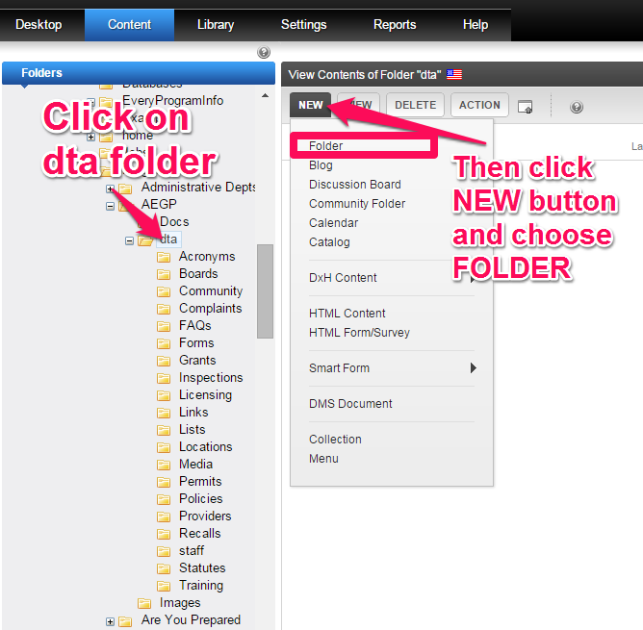
Next, enter the folder name and click the ADD FOLDER button
