- Log in to the Ektron Workarea and navigate to the folder you want to delete content from.
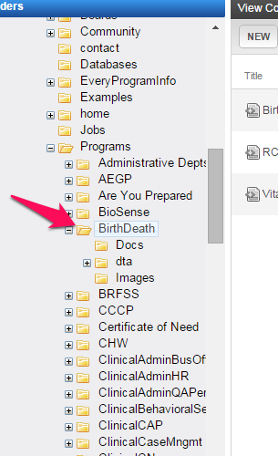
- Open the dta folder and click on the specific folder you want to delete the content block from.
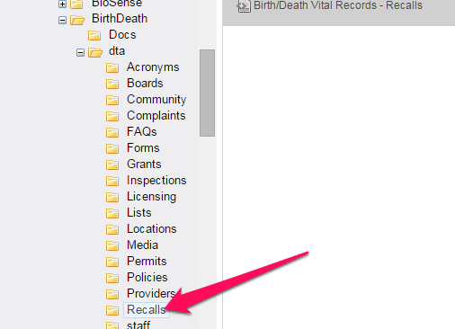
- In the right pane, click on the content block you want to delete to select it

- Click on the Delete button and select CONTENT.
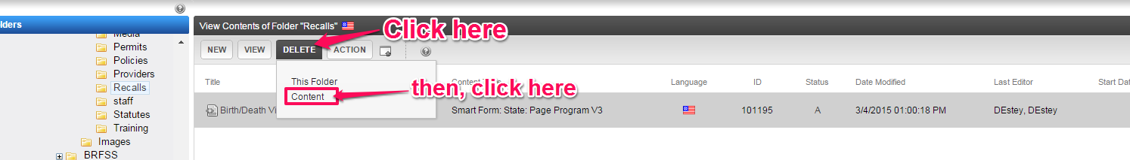
- When the following window appears, click the check-box next to the content block you want to delete, then click the DELETE CONTENT button.
- When the dialog box below appears, click OK and the content block is deleted.
