Overview
Admin Level personnel are responsible for updating the initiatives link on the homepage.
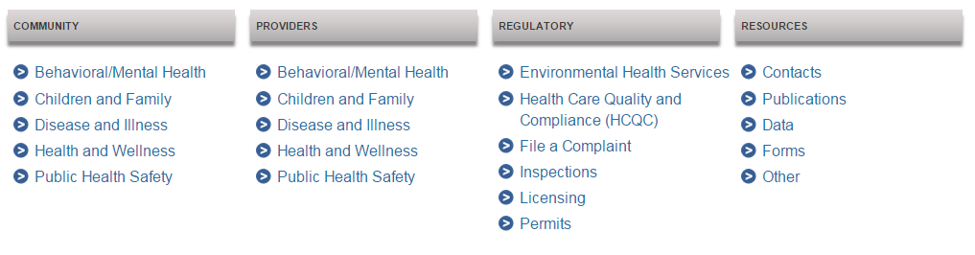
Procedure
- Open the Ektron workarea and navigate to the dpbh.nv.gov / content / home / features folder.
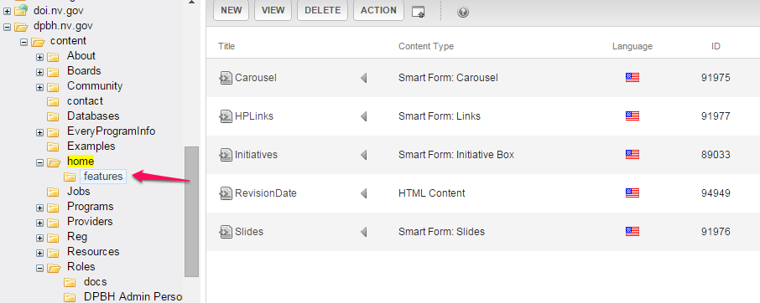
- Click on the name of the HPLinks content block or click on the arrow directly to the right of the name and choose the Edit option.
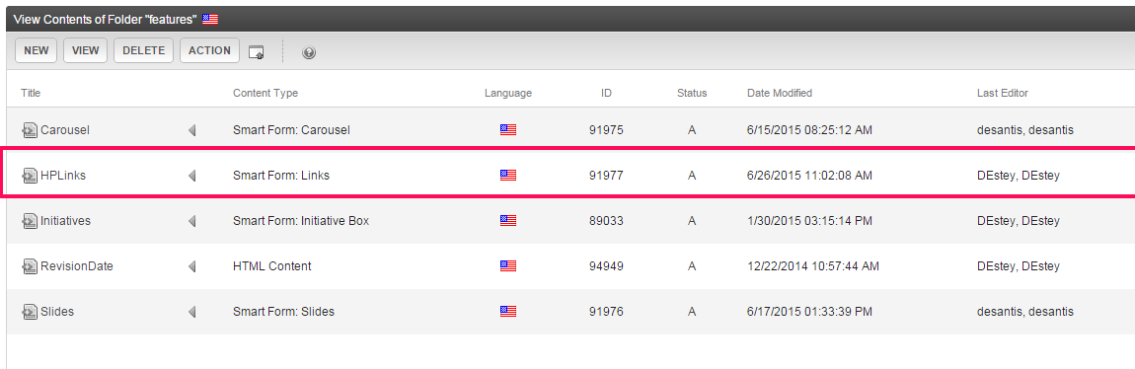
- Use the Create, Edit and Delete Hyperlinks in a Link / List Field procedure on http://it.nv.gov to perform the rest of the update.

