- Open the DPBH Resources Program Cross Reference Information sheet (excel document) and make sure it has been updated with all programs. You will use this list to add each program to each category seen on http://dpbh.staging.nv.gov/Resources/Resources/.
  - Once updated, make sure this document is sorted by Column D (Program) and Column C (Program Category). Important Note: This provides the order in which each programs should be added so they will not need to be manually alphabetized which would be difficult and time consuming with the number of programs involved.
- Login to Ektron and go to dpbh.nv.gov > Resources folder or to dpbh.nv.gov > Reg (Regulatory) folder depending on which program you wish to add.
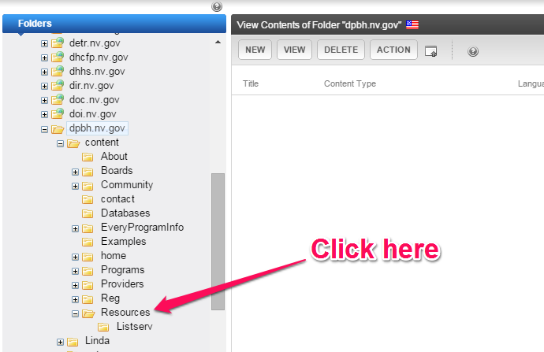
- Click on the content block for the appropriate category.
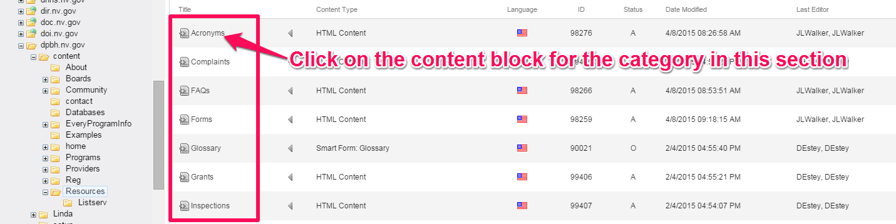
- Click the EDIT button
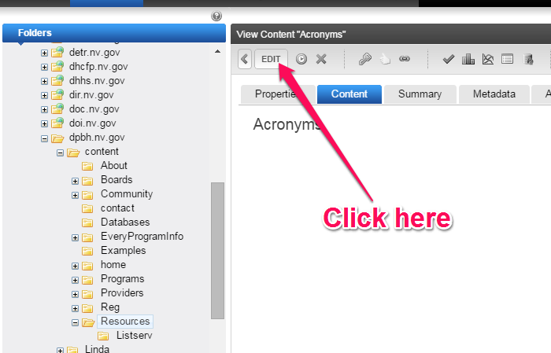
- Click the Metadata tab
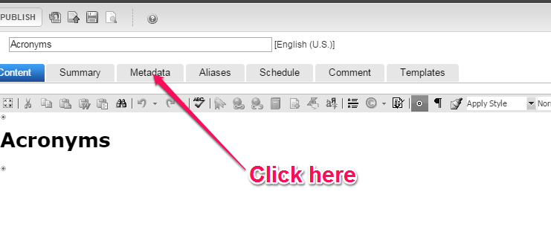
- Scroll down until you locate the Main List: (List Summary) area and click the Edit button
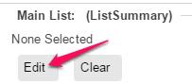

- When the navigator opens navigate to dpbh.nv.gov > Content > Programs and navigate to the first program shown in the DPBH Resources Program Cross Reference Information sheet (excel document) verifying that all programs are in alphabetical order by program. 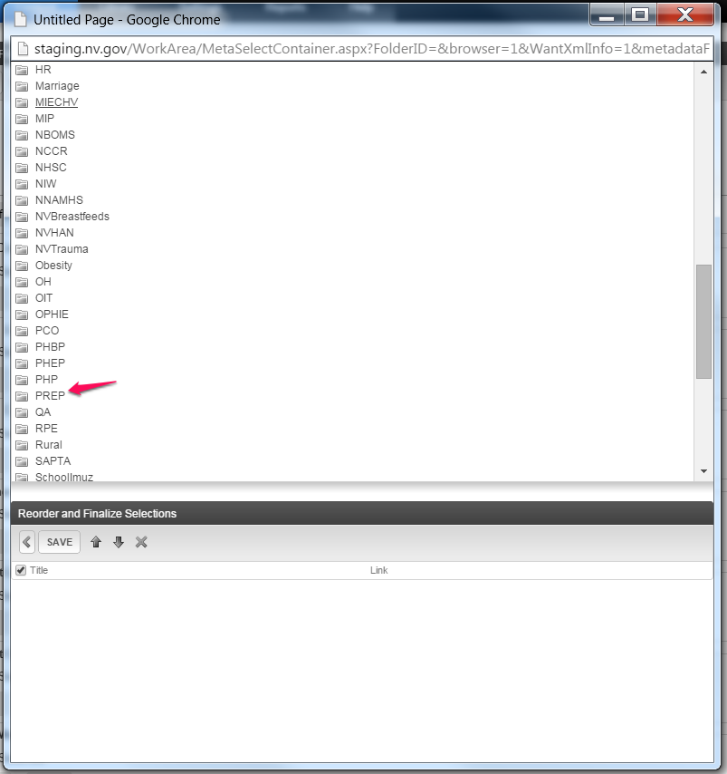
- Open the dta folder
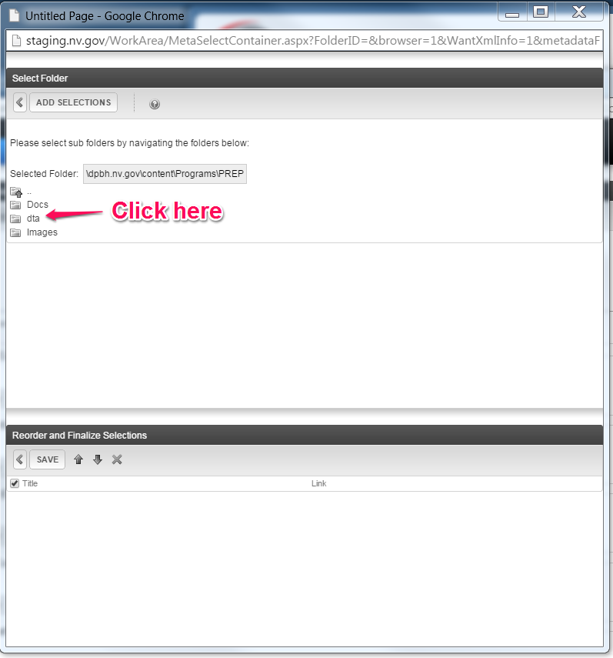

- Click on the appropriate category
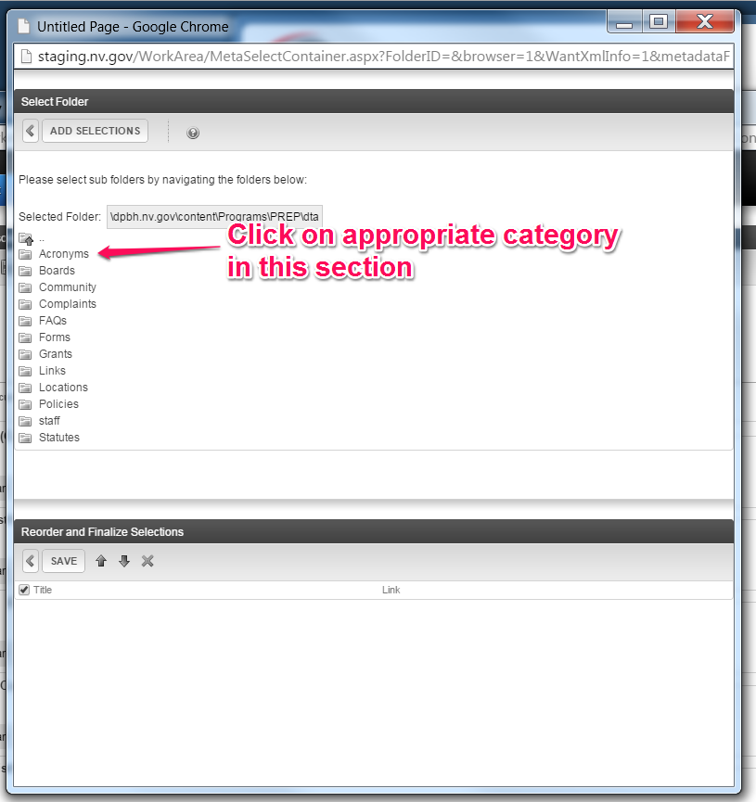

- Click the ADD SELECTIONS button.
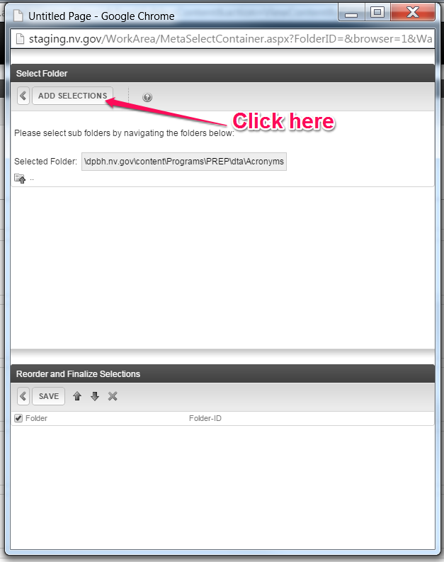

- The information will be populated in the Reorder and Finalize Selections area, then click the SAVE button. Note: You can add multiple programs before clicking the SAVE button.
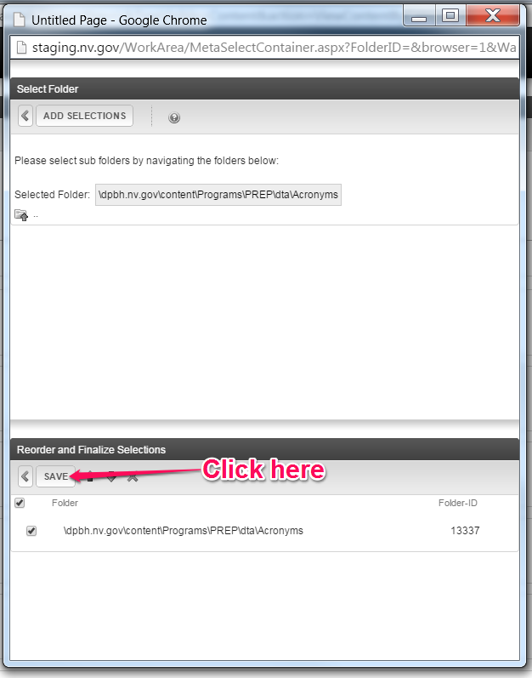
Click the Save Button will add the program folder(s) to the Main List: (ListSummary) area of the smart form.
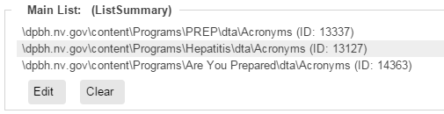
- Repeat steps 8-12 for each program.
- Repeat entire procedure for each category

