- In a browser window go to http://www.google.com/analytics/ and sign-in to your account.
- Click Access Google Analytics
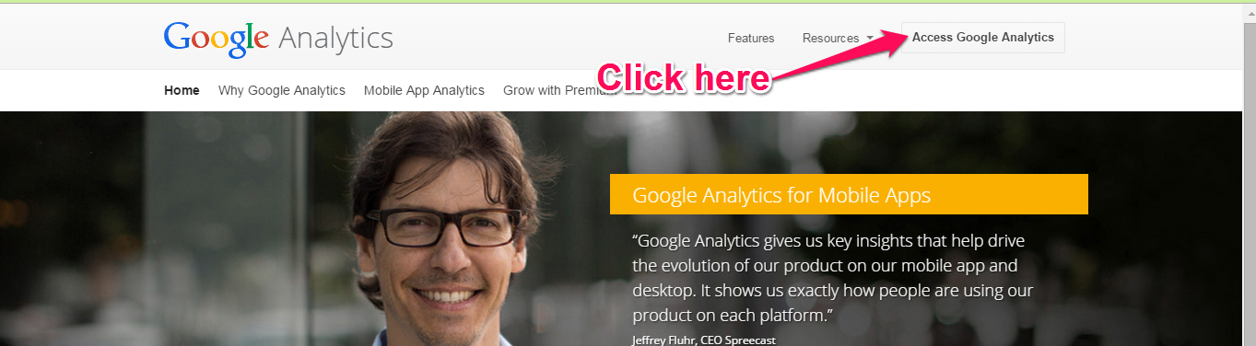
- In the left column, click on the text DPBH.nv.gov site
- In the left pane, click on the BEHAVIOR tab.
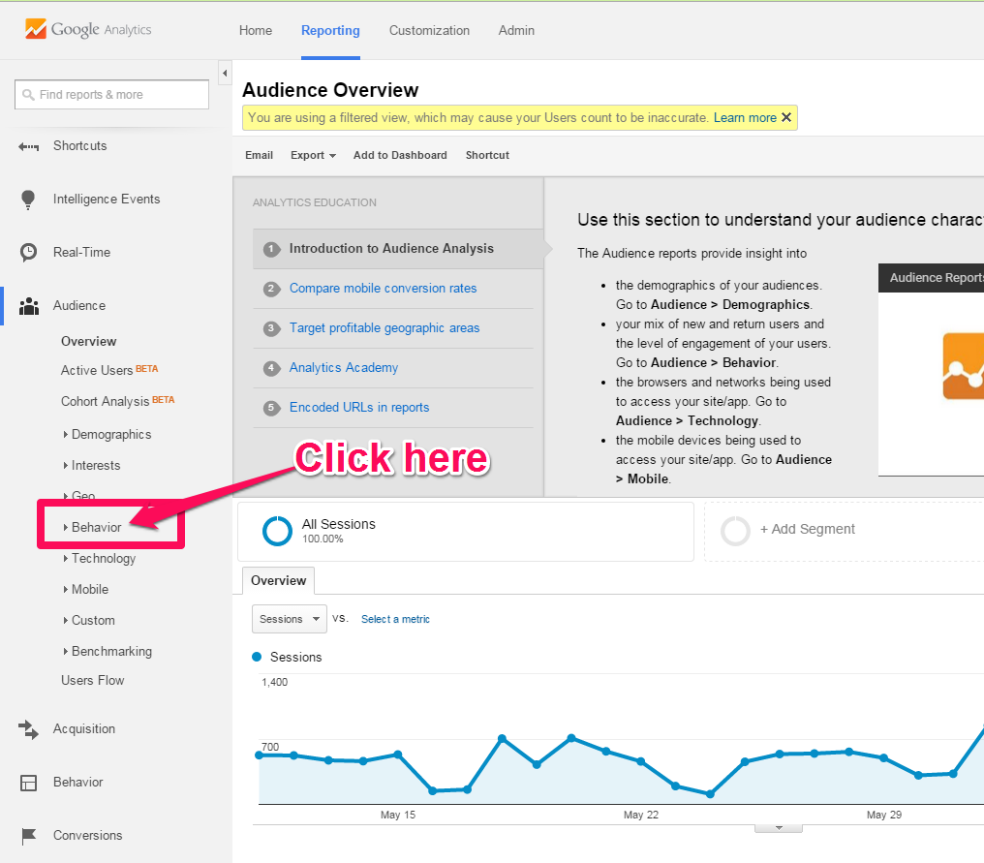
- Next, click on Site Content and then All Pages
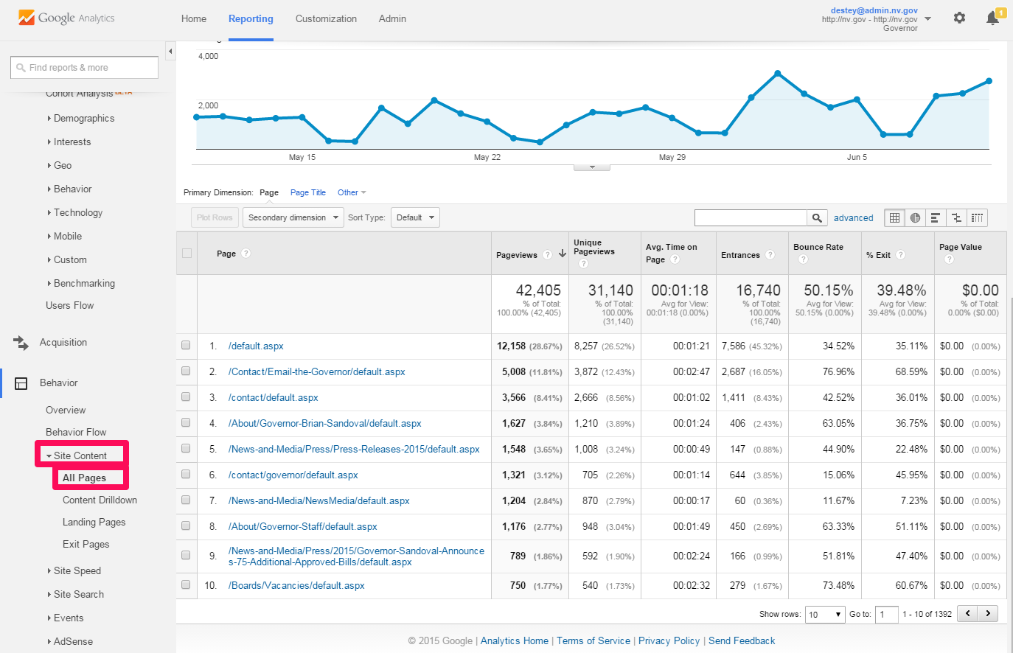
- The top 10 items will appear in the Page column.
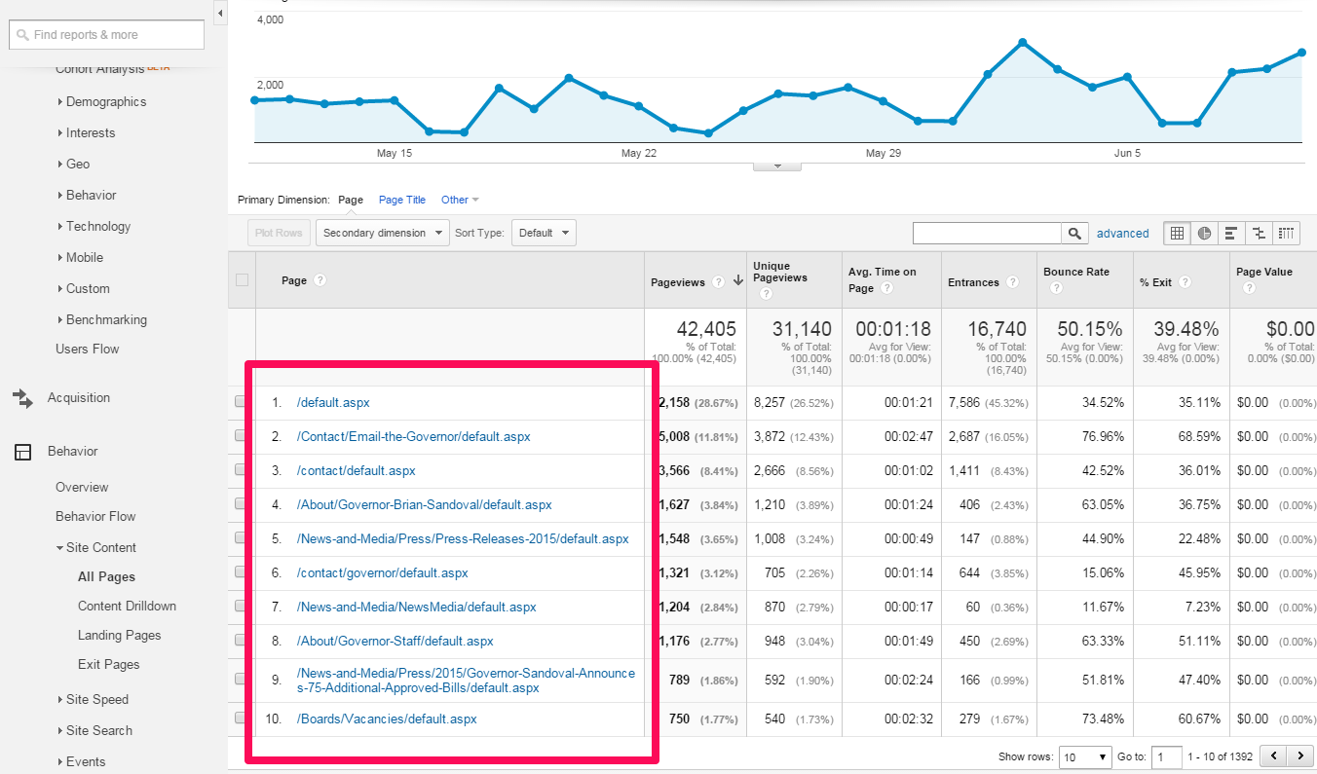
- Choose the Homepage Quick links from those top ten pages that users visit the most.
Note: usually if a default.aspx page is listed that is the site homepage. Skip it and pick the next few links as the Quick Links.
- In the Ektron Workarea navigate to the home > features folder click on the content block entitled “HPLinks”
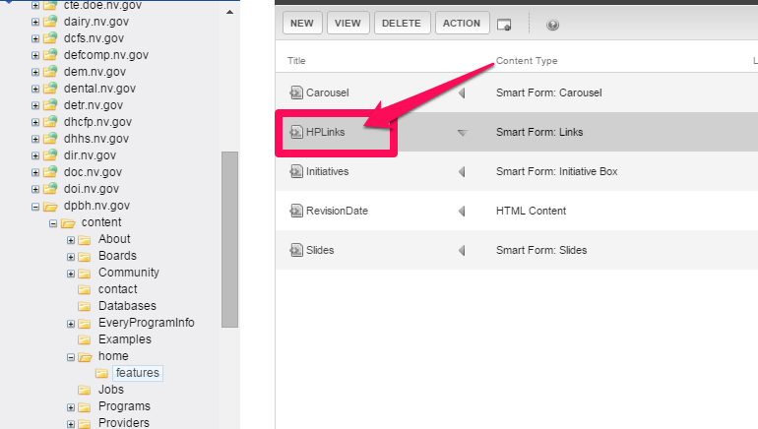
- Click the EDIT button
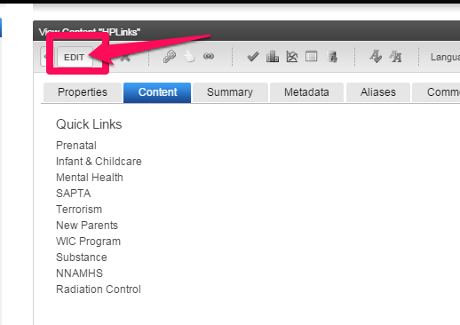
NOTE: you may need to remove a link in order to add a new one otherwise too many items in this section will push down the content and carousel on the homepage leaving prime website real estate space empty and creates a poor webpage format.
- To add a new link click the call out button above or below where you want to insert the new link and choose the appropriate selection (Insert Above or Insert Below).
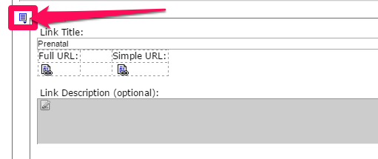
- To delete a link, click the call out containing the link to be deleted and choose REMOVE from the drop-down menu.

