Overview:

The DPBH Overview page, the Programs Page and the Regulatory Page are built with each section in its own content block and metadata is used to display the information on the main landing pages (DPBH Overview, Programs, Regulatory pages). These pages also get updated the same way.
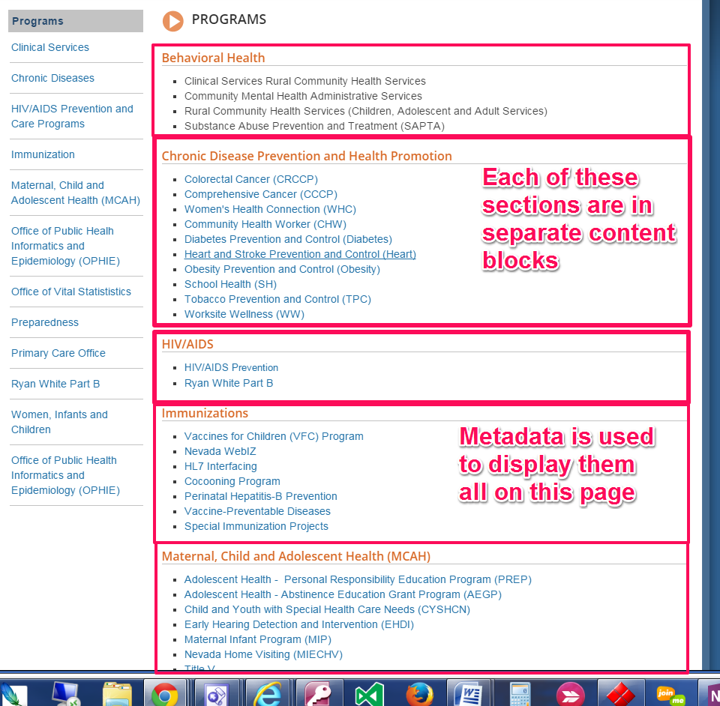

Procedure
- Log in to Ektron and go to the appropriate folder depending on which section will be updated:
  - dpbh.nv.gov > content > About > Overview
  - dpbh.nv.gov > content > Programs
  - dpbh.nv.gov> content > Reg
- Click on the appropriate content block name for the section you wish to update.
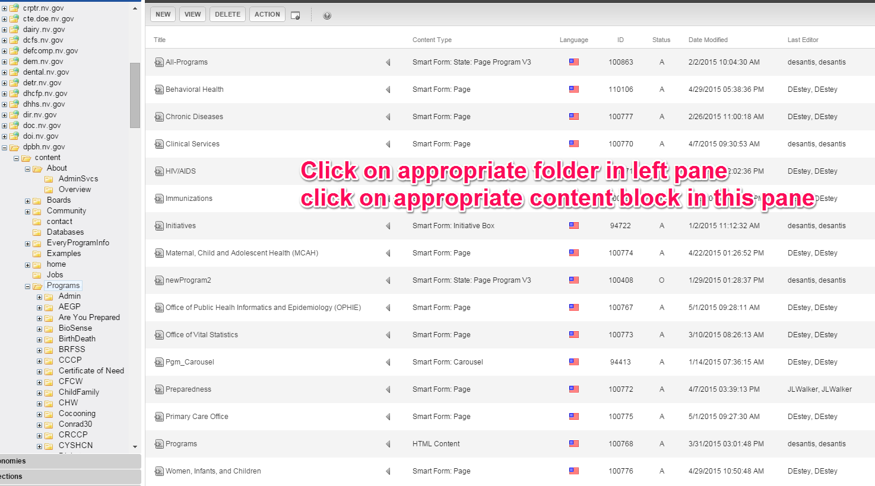
- Click on the EDIT button.
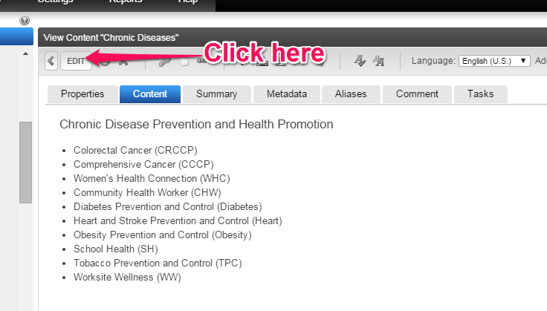
- Add, edit and delete text or hyperlinks as necessary. See procedures on http://it.nv.gov/web on how to add, edit and delete content in a smart form and how to add, edit or delete hyperlinks in a Rich Area Text field.

